α-MATHEMATICS

Grade 11 Alpha Mathematics

June Examination 2022

Examiner: L Liebenberg Time: $2$ $\frac{1}{2}$ hours
Moderator: A Muller Total: 150

INSTRUCTIONS AND INFORMATION
Read through the following instructions before answering the question paper.
1. | This question paper consists of 8 pages, an answer sheet and a diagram sheet.
2. | Answer ALL 7 questions.
3. | Number the answers according to the numbering system used in this question paper.
4. | Non-programmable calculators may be used, unless otherwise indicated in the question.
5. | Unless indicated otherwise, all answers, where necessary, must be given correct to two decimal places.
6. | Cleary show all calculations, diagrams, graphs etcetera that you have used in determining the answers.
7. | Answers only will not necessarily be awarded full marks.
8. | The diagrams are not necessarily drawn to scale.
9. | All angles are given in radians. Answers must also be given in radians where necessary.
10. | Write neatly and legibly.

Question 1 |  |  | [20 marks]
This question must be answered on the answer sheet.
Every question has ONLY one correct answer. Mark the correct answer with an X on the answer sheet.

1.1 | The absolute value of a negative number ___________. |  |  | (2)
 | A | does not exist
 | B | is undefined
 | C | exists, but the answer will always be positive
 | D | is equal to zero
1.2 | The power series is given:  $${\left(1+x\right)}^{n}=1+nx+\frac{n\left(n-1\right)}{2!}x^{2}+\frac{n\left(n-1\right)\left(n-2\right)}{3!}x^{3}+…$$  Which of the following statements is FALSE? |  |  | (2)
 | A | If $n$ is a fraction the series is infinite.
 | B | If $n$ is a positive integer the series will end with $x^{n}$.
 | C | $n$ cannot be negative.
 | D | The series will converge if $\left|x\right|<1.$
1.3 | $$\sum_{k=1}^{3}{k^{3}=}$$ |  |  | (2)
 | A | $$1+2+3$$
 | B | $$1+8+27$$
 | C | $$3^{1}+3^{2}+3^{3}$$
 | D | $$k+k+k$$

1.4 | $$\frac{1}{\sec^{2}{π}+3}=$$ |  | (2)
 | A | $0,98$
 | B | $4$
 | C | $0,25$
 | D | $3$
1.5 | Given the function $f(x)$ and its inverse $f^{-1}(x)$. Which of the following statements is FALSE? |  | (2)
 | A | $f\left(x\right)$ must be a one-to-one function.
 | B | $f^{-1}(x)$ has a domain identical to the domain of $f$.
 | C | $f^{-1}(x)$ has a domain identical to the range of $f$.
 | D | $f^{-1}(x)$ is a reflection of $f(x)$ over the line $y=x$.
1.6 | The general term of the binomial expansion is:  $$\left(\begin{matrix}n \\ r\end{matrix}\right).a^{n-r}.b^{r}$$  If the 5th term in the binomial expansion of ${\left(2x+3b\right)}^{10}$ has to be determined, the value of $r=$ |  | (2)
 | A | 5
 | B | 2
 | C | 3
 | D | 4

1.7 | The function $f\left(x\right)=2x^{4}+3x^{3}+3x^{2}+3x+1$ has a zero at |  | (2)
 | A | $$-\frac{1}{2}$$
 | B | $$\frac{1}{2}$$
 | C | $-2$
 | D | $0$
1.8 | If $x=1+\sqrt{3}$ is a zero for a certain polynomial then the following statement is FALSE: |  | (2)
 | A | $x=1-\sqrt{3}$ is also a zero.
 | B | $\left(x-1+\sqrt{3}\right)\left(x-1-\sqrt{3}\right)$ is a factor.
 | C | $-1-\sqrt{3}$ is also a zero.
 | D | $x^{2}-2x-2$ is a factor.
1.9 | Given that $\left|x\right|>-2$ then: |  | (2)
 | A | $x∈R$
 | B | $x>-2$ and $x<2$
 | C | there are no solutions for $x$
 | D | $-2<x<2$
1.10 | Given that the range of $f(x)=\cos{x}$ is $y∈\left[-1 ;1\right]$ then |  | (2)
 | A | the domain of $f(x)$ $x∈\left[-1 ;1\right]$
 | B | the range of $f^{-1}(x)$ $y∈\left[-1 ;1\right]$
 | C | the domain of $f^{-1}(x)$ $y∈\left[-1 ;1\right]$
 | D | the domain of $f^{-1}(x)$ $x∈\left[-1 ;1\right]$

Question 2 |  |  | [30 marks]
2.1 | Solve for $x$:
 | 2.1.1 | $\left|10-x\right|=-4$ |  | (2)
 | 2.1.2 | $\left|3x-6\right|=x+2$ (hint: make use of the definition) |  | (5)
 | 2.1.3 | $\left|2x-10\right|<20$ AND $x^{2}≥25$ |  | (7)
 | 2.1.4 | $\frac{-8}{\left|x-4\right|}<2$ |  | (4)
2.2 | Given that $f\left(x\right)=-2\left|x+4\right|+6$ and $g\left(x\right)=4$.
 | 2.2.1 | Sketch the graphs of $f$ and $g$ on the same set of axes on the diagram sheet. |  | (8)
 | 2.2.2 | Use your sketch in question 2.2.1 to determine for which values of $x$, $f(x)≥g(x)$. |  | (2)
 | 2.2.3 | Determine the coordinate of the salient point of $h,$ if $h$ is the reflection of $f$ over the $y$-axis. |  | (2)

Question 3 |  |  | [10 marks]
3.1 | In the diagram below P is the midpoint of AB and Q is the midpoint of AC. APQ is the sector of a circle with centre A.
 | 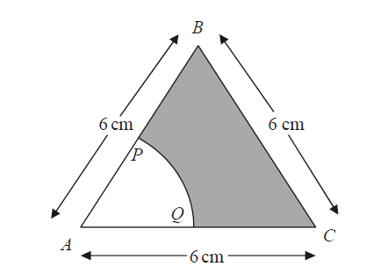
 | 3.1.1 | Write down the magnitude of $A\hat{B}C$. |  | (2)
 | 3.1.2 | Give the length of the radius of the circle. |  | (2)
 | 3.1.3 | Determine the area of the shaded part. |  | (6)

Question 4 |  | [24 marks]
4.1 | Use Mathematical Induction to show that for all natural numbers $n:$  $$\sum_{r=1}^{n}{\left(3r^{2}-3r\right)=n^{3}-n}$$ |  | (13)
4.2 | Decompose the expression into partial fractions  $$\frac{1}{x^{4}+x^{2}}$$ |  | (11)

Question 5 |  |  | [19 marks]
5.1 | Given the Binomial Theorem  $${\left(a+b\right)}^{n}=\sum_{r=0}^{n}{\left(\begin{aligned}n \\ r\end{aligned}\right)a^{n-r}b^{r}}$$  $=\left(\begin{matrix}n \\ 0\end{matrix}\right)a^{n}+\left(\begin{matrix}n \\ 1\end{matrix}\right)a^{n-1}b+\left(\begin{matrix}n \\ 2\end{matrix}\right)a^{n-2}b^{2}+…+\left(\begin{matrix}n \\ n-1\end{matrix}\right)ab^{n-1}+\left(\begin{matrix}n \\ n\end{matrix}\right)b^{n}$  Determine the constant term in the expansion of ${\left(6a-\frac{2}{3a}\right)}^{8}$. |  |  | (6)
5.2 | Make use of the formula for a power series to answer this question.  $${\left(1+x\right)}^{n}=1+nx+\frac{n\left(n-1\right)}{2!}x^{2}+\frac{n\left(n-1\right)\left(n-2\right)}{3!}x^{3}+…$$
 | 5.2.1 | Expand ${\left(1-2x\right)}^{-2}$ and simplify the first 4 terms. |  | (7)
 | 5.2.2 | For which values of $x$ will the series in question 5.2.1 converge? |  | (3)
5.3 | Which number will be in the 5th position in the 10th row of Pascal’s triangle? |  |  | (3)

Question 6 |  |  | [17 marks]
6.1 | Given that $f\left(x\right)=x^{4}-6x^{3}+22x^{2}-54x+117$ with a zero of $3+2i$. Solve for $x$ in $C\left[x\right]$ if $f\left(x\right)=0$. |  |  | (9)
6.2 | A polynomial given as $x^{3}+ax^{2}+bx+c$ has zero’s at $x=-2+\sqrt{3}$and $x=2$.  Determine the values of $a, b$and $c$. |  |  | (8)
Question 7 |  |  | [30 marks]
Given:
$$g\left(x\right)=sin\left(2x-\frac{π}{4}\right)$$

7.1 | The inverse of the function is not a function unless the domain of $f(x)$ is restricted. Give an interval of the domain such that the inverse will be a function. |  |  | (3)
7.2 | Determine the inverse in the form $g^{-1}\left(x\right)=$ |  |  | (5)
7.3 | Determine the value of $g\left(\sqrt{2}\right)$. |  |  | (2)
7.4 | Determine the value of $x$ if $g\left(x\right)=0,5$ and $x$is an acute angle. |  |  | (4)
7.5 | Determine the value of $g^{-1}\left(1\right)$. |  |  | (2)
7.6 | Given that $h\left(x\right)=2\arctan{x}$,
 | 7.6.1 | Write down the equations of the asymptotes of $h.$ |  | (5)
 | 7.6.2 | Sketch the graph of $h$ on the diagram sheet. |  | (2)
 | 7.6.3 | For which values of $x$ is $h\left(x\right)<\frac{π}{2}$? |  | (2)
 | 7.6.4 | Write down the domain of $h^{-1}$, that is the inverse of $h$. |  | (2)
 | 7.6.5 | Write down the equation of $k$. $k$ is formed by applying the following translations to $h$.  - reflect over the $x$-axis  - move 3 units to the right  - move 4 units up |  | (3)
- END OF QUESTION PAPER -

α-MATHEMATICS

Grade 11 Alpha Mathematics

June Examination 2022 Answer sheet

Name and Surname: ___________________________________________________

Question  Total | 1  [20] | 2  [30] | 3  [10] | 4  [24] | 5  [19] | 6  [17] | 7  [30] |  | TOTAL  150
Learner
mark

Question 1
1.1 | A | B | C | D
1.2 | A | B | C | D
1.3 | A | B | C | D
1.4 | A | B | C | D
1.5 | A | B | C | D
1.6 | A | B | C | D
1.7 | A | B | C | D
1.8 | A | B | C | D
1.9 | A | B | C | D
1.10 | A | B | C | D

Question 2
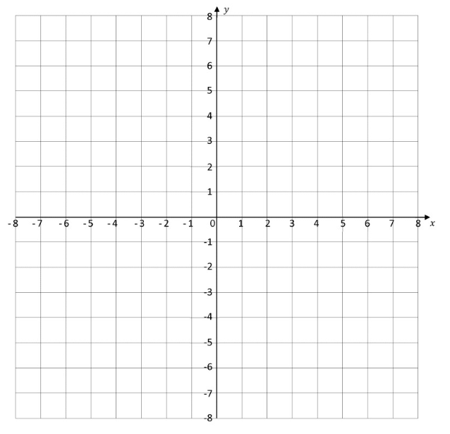
2.2.1

Question 7
7.6.2


