Alpha Mathematics

Grade 12 Exam Paper
October 20, 2017
Total: 200 marks Time: 3 hours

INSTRUCTIONS
1. Answer all questions on this exam paper and hand it in. Remember to write your name and ID number on the front sheet.
2. Write neatly and legibly.
3. Non-programmable calculators may be used.
4. The diagrams on the question paper are not necessarily drawn to scale.
5. All angles are given in radians. Answers must be given in radians if necessary.
6. Unless indicated otherwise, all answers, where applicable must be given correct to two decimal digits.
7. This paper consists of 10 questions and 3 formula sheets.
8. Question 1 consists of 10 multiple choice questions. Answer it on the answer sheet. This answer sheet is in the front of the paper. Please do NOT remove it.
9. For all other questions, all necessary calculations must be shown clearly.
The correct answer alone will not necessarily lead to full marks.
10 There is extra space at the end of the paper. Clearly indicate if you use this space for a question.

QUESTION 1 [20 marks]
Answer this QUESTION on the answer sheet by marking A, B, C or D with an X.
Please don’t remove this page from the paper. The questions count 2 marks each.
1.1 The equation of $f(x)$ of which the graph is given:
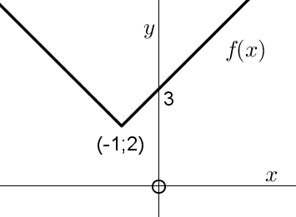
(A) $f\left(x\right)=\left|x-1\right|+2$
(B) $f\left(x\right)=\left|x-1\right|+3$
(C) $f\left(x\right)=\left|x+1\right|+2$
(D) $f\left(x\right)=\left|x+1\right|+3$

1.2 Give the domain of $g\left(x\right)=2arcsine(2x)$.
$x∈…$
(A) $[0;2]$ (B) $[-2;2]$ (C) $[-1;1]$ (D) $[-\frac{1}{2};\frac{1}{2}]$

1.3 Give the range of $g\left(x\right)=2arcsine(2x)$.
$y∈…$
(A) $[-2π;2π]$ (B) $[-π;π]$ (C) $[-\frac{π}{2};\frac{π}{2}]$ (D) $[-\frac{π}{4};\frac{π}{4}]$

1.4 Given $g\left(x\right)=\frac{(x+1)(x-1)(x+2)}{(x+4)(x+2)}$. The graph of $g(x)$ will, at $x=-2$,
(A) intercept the $x$-axis (B) have a vertical asymptote
(C) have an open dot (D) have a jump discontinuity

1.5 For which value(s) of $k$ will the function $f\left(x\right)=\left\{\begin{matrix}\frac{x+3}{x^{2}-9} & as x≠-3 \\ & \\ k & as x=-3\end{matrix}\right.$be continuous
at $x=-3$?
A $k=3$ B $k=-3$ C $k=\frac{1}{6}$ D $k=-\frac{1}{6}$

1.6 Use the binomial theorem and determine the coefficient of $a^{5}b^{4}$ in ${\left(3a-\frac{b}{3}\right)}^{9}$
(A) 126 (B) $-$378 (C) 378 (D) No one

1.7 For which value of $x$ will $x+\frac{1}{x}$ have a local (relative) maximum turning point:
(A) 2 (B) -2 (C) 1 (D) -1

1.8 If $f$ is a function such that $f^{'}\left(x\right)>0$ and $f"(x)>0$ for all $x$, then the following can be a graph of $y=f(x)$:
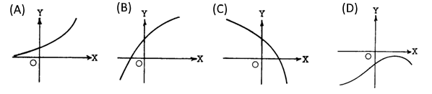

1.9 A possible function of which the following is true:
$$f^{'}\left(x\right)=-f(x)$$
(A) $e^{1-x}$ (B) $e^{x-1}$ C) $ln⁡(1-e^{-x})$ (D) $ln⁡(e^{-x})$

1.10 If $\int_{a}^{b}{f(x)}dx=5 and \int_{a}^{b}{g(x)}dx=-1$, which statement(s) must be true:

I $f\left(x\right)>g(x)$ for $a≤x≤b$
II $\int_{a}^{b}{\left(f\left(x\right)+g(x)\right)}dx=4$

(A) Only I (B) Only II (C) Both I and II (D) Neither

Answer the following questions on the lines provided, on the exam paper, after each question.
QUESTION 2 [20 marks]
2.1 The distribution of a virus through a city is represented by the function
$$N=\frac{10094}{3+100e^{-0,5t}}$$
where $N$ is the number of people infected by the virus after $t$ days.
(a) How many people were initially infected with the virus? (2)
(b) After how many days will 1265 people be infected? (4)
(c) Determine an expression of the rate at which people are infected. (4)
(d) Are there more or less people infected than on the previous day? Motivate. (2)
2.2 The function $f\left(x\right)=x^{3}+7x^{2}+17x+15$ has a zero at $x=-2+i$. Determine all
possible $x$-intercepts of $f$. (4)
2.3 When $\sqrt[3]{1+2x}$ is expanded with the power series, the fourth term is equal to $ax^{3}$.
Determine the value of $a$. (4)
QUESTION 3 [20 marks]
3.1 (a) i) Show that $\frac{1+i}{1-i}=i$. Work in rectangular form. (3)
ii) Hence determine the value of $\frac{{\left(1+i\right)}^{17}}{{\left(1-i\right)}^{16}}$. (3)
(b) i) Write ($1+i$) and $(1-i)$ in polar form and use root form and $π$. (4)
ii) Now determine the value of $\frac{{\left(1+i\right)}^{17}}{{\left(1-i\right)}^{16}}$ by using de Moivre’s theorem.
Give the answer in rectangular form. (4)
3.2 Mathematical induction can be done using the following steps:
Step1: Prove that the statement is true for $n=1$.
Step 2: Accept that the statement is true for $n=k$.
Step 3: Prove that the statement is then also true for $n=k+1$.
Step 4: Draw conclusions.
Write down only the calculations of Step 3 when the following is proved by mathematical induction: (6)
$${\sum_{p=1}^{n}{x^{p-1}}=\frac{1-x^{n}}{1-x}}^{}$$

QUESTION 4 [19 marks]
Given $f\left(x\right)=\left|ln⁡(x+2)\right|$ and $g\left(x\right)=-3x-3$.
4.1 The graphs of $f$ and $g$ intercept at $(-1;0)$ and another point. Show that this point’s $x$ value can be calculated by solving the equation $e^{3x+3}=x+2$. (3)
4.2 Hence use Newton's method with the equation given in question 4.1 and determine this
$x$ value correctly to four decimal places. Show clearly how you use Newton's method.
Use $x=-1,8$ as first approximation. (5)
4.3 The sketch below already has the graph of $y=g\left(x\right)$.
(a) Sketch the graph of $y=f(x)$on the same set of axes. Clearly show the intercepts
with the axes, the intercepts of the graphs and any possible asymptotes. (5)
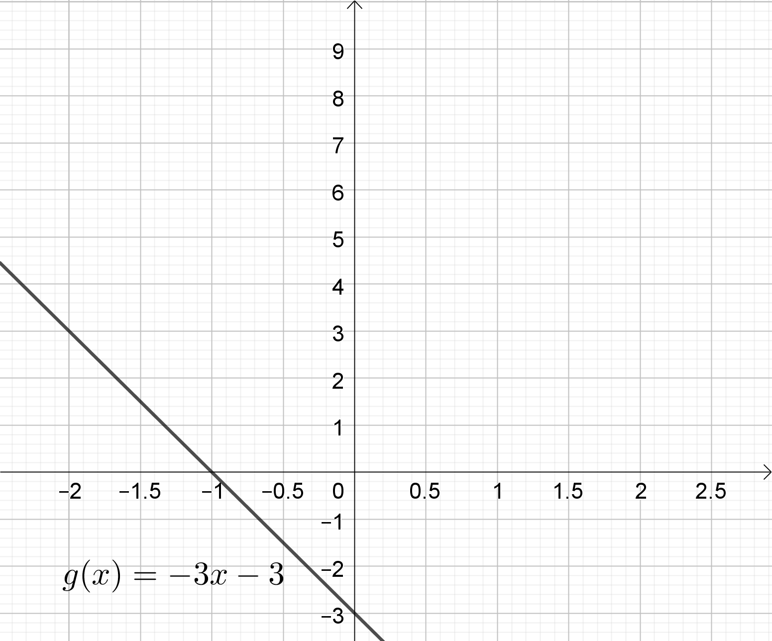
(b) Use $x=-1,9$ and $x=-1$ as intercepts of the two graphs for the following questions, as well as the graph of question 4.3
i Give the values of $x$ for which $f\left(x\right)<g(x)$. (2)
ii Give the values of $x$ for which $f^{'}\left(x\right).g^{'}\left(x\right)>0$. (2)
4.4 Determine the inverse function, $f^{-1}(x)$, if $f\left(x\right)=sin⁡(x+2)$. (2)

QUESTION 5 [12 marks]
5.1 Given the system of equations:
$$\begin{matrix}ax & & +2z \\ & 2y & +z \\ 4x & -y & \end{matrix} \begin{matrix}= & 9 \\ = & 8 \\ = & 2a\end{matrix}$$
It is given that $x=1$. Use Cramer’s rule and determine the value of $a$. Clearly show the
matrices with which you work. (7)
5.2 The sketch shows a circle with centre O and radius $r$. A and B are points on the circumference of the circle and obtuse angle $A\hat{O}B=θ$. The area of the sector that is shaded is 96 and the arc length AB is equal to 24.
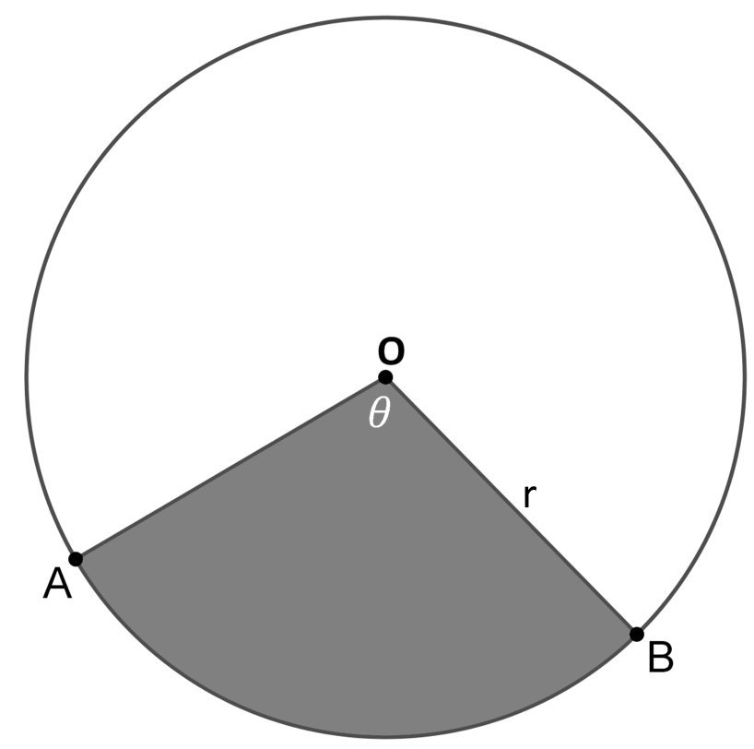
(a) Calculate the radius of the circle. (4)
(b) Calculate the size of the angle $θ$ (1)
QUESTION 6 [25 marks]
6.1 Differentiate the following using basic principles:
$$f\left(x\right)=\frac{2}{1-4x}$$
(5)
6.2 Determine the following derivatives:
(a) $f'(x)$ if $f\left(x\right)=log⁡(x^{2})×bgcos\frac{4}{x}$ (5)
(b) $D_{x}\left[ln⁡\left(\frac{tanx}{1+2x}\right)\right]$ (4)
6.3 (a) $e^{siny}-x+aπ=x^{3}.siny+ky$. Use implicit differentiation and determine $\frac{dy}{dx}$. (6)
(b) Determine the values of $k$ and $a$ if the gradient on the graph at the point $(1;π)$
is equal to 1. (5)

QUESTION 7 [22 marks]
Given $f\left(x\right)=x^{2}e^{x}$.
7.1 Determine the $x$ intercepts of $f$ with the axes. (2)
7.2 Given that $f$ has stationary points at (0;0) and $(a;0,54)$.
Use $f'$ and determine the value of $a$. (4)
7.3 Determine $f"(x)$ and use this to determine the nature of the stationary points. (6)
7.4 Use $f"$and determine the $x$-values of the point of inflection of $f$. It is not necessary to show that these are points of inflection. (4)
7.5 The point of inflection of $f$ is at $(b;0,38)$ and $(c;0,19)$ with $b<c$.
Use this information and make a sketch of the graph of $y=f(x)$ on the axes
below for $x∈[-5;\frac{1}{2}]$. Show all the values calculated in 7.1 to 7.4 on your graph. (6)
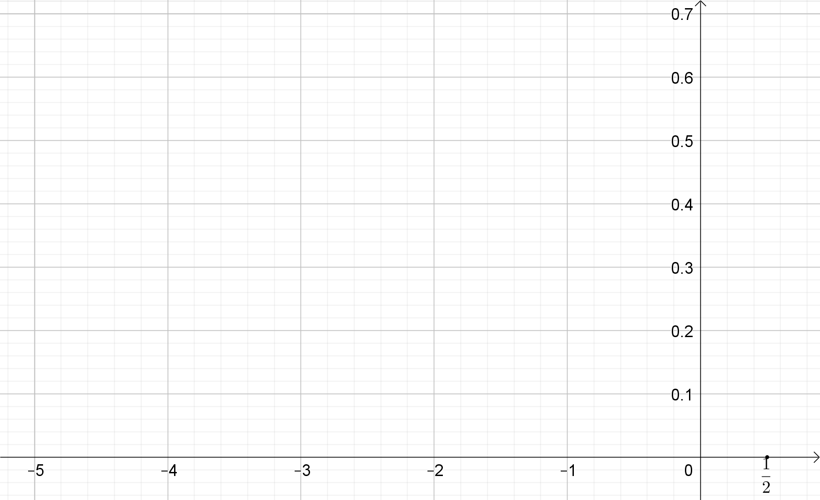

QUESTION 8 [26 marks]
8.1 The sketch shows the graph of $f\left(x\right)=\frac{x^{2}+2}{x^{2}-4x}$: The graph has a minimum turning point at A and a maximum turning point at B.
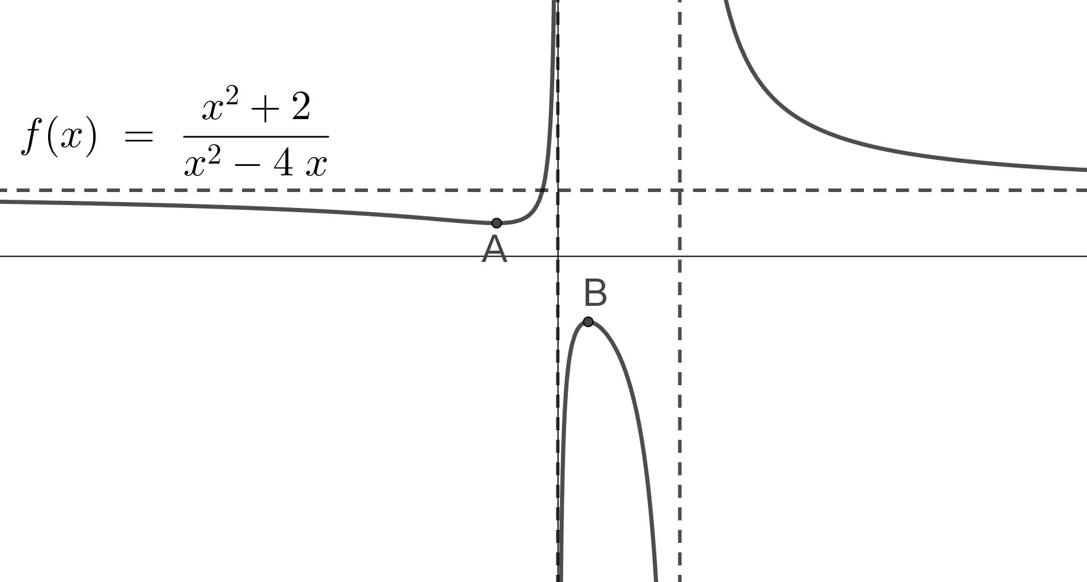
(a) Determine the equations of the asymptotes. (3)
(b) Give the domain of $f$. (2)
(c) Determine the range of $f$. (8)
8.2 Determine the following integrals:
(a) $∫\left(9^{x}+x^{9}-\frac{9}{x}\right)dx$ (4)
(b) $∫\sin^{5}{2x}.cos2x dx$ (4)
(c) $\int{sin}{5x}.\cos{2x}dx$ (5)
QUESTION 9 [20 marks]
9.1 (a) Expand $\frac{16x^{2}-9x+3}{(x-1)(4x^{2}+1)}$ into partial fractions. (6)
(b) Hence determine $\int{\frac{16x^{2}-9x+3}{(x-1)(4x^{2}+1)}}dx$. (4)
9.2 Determine the value of $\int_{1}^{3}{{(x}^{2}+x)}dx$ by using a Riemann sum. (10)
QUESTION 10 [16 marks]
10.1 (a) Use integration by parts and determine $\int{x.lnx}dx$ (7)
(b) The sketch shows the graph of the function $f(x)=x.lnx$ as well as the area
included by the graph, the $x$-axis and the line $x=4$.
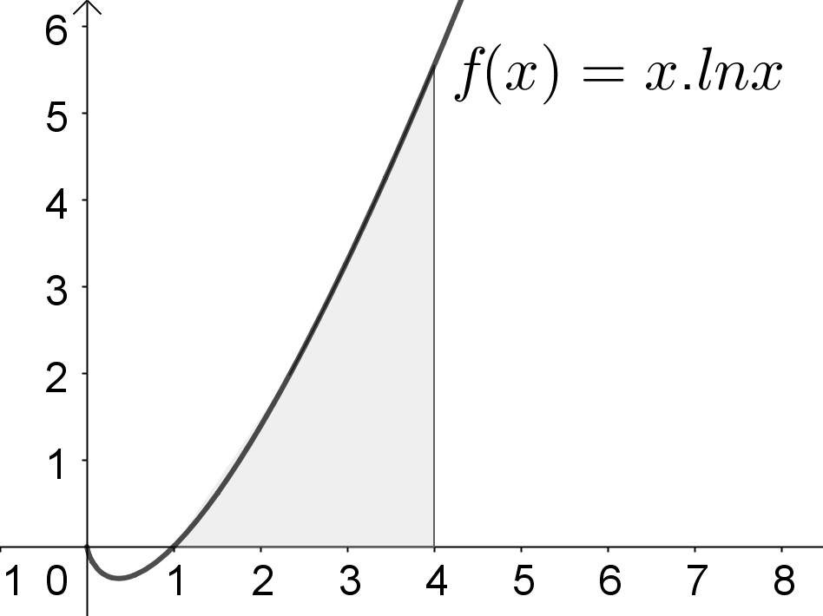
Use your answer from question 10.1 (a) and calculate this area. (3)
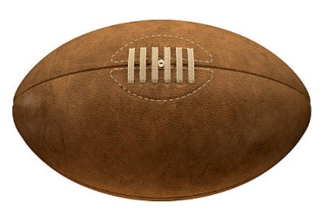
10.2 A rugby ball can be formed by rotating the graph $y^{2}=9(1-\frac{x^{2}}{a})$ around the $x$-axis between the points $x=-6$ en $x=6$.
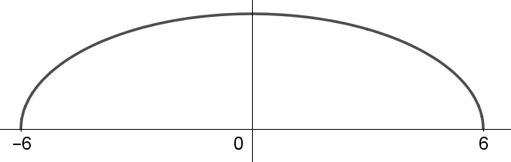
The volume of the body of rotation which is hence formed is equal to $72π$.
Calculate the value of $a$. (6)

Extra Space

