α-WISKUNDE

Alpha Wiskunde Graad 10 / Alpha Mathematics Grade 10
Finale Eksamen 2017 / Final Examination 2017

MEMORANDUM

Totaal / Total: 130 punte / marks

Eksaminator / Examiner: Hennie Botha
Moderators: Anna Muller

Hierdie memorandum bestaan uit 10 bladsye. /
This memorandum consists of 10 pages.

Vraag / Question 1 [20 punte / marks]
NR. | ANTWOORD ANSWER | BEREKENINGE (nie vir nasien doeleindes nie)  CALCULATIONS (not for marking purpose) | PUNTE MARKS
1.1 | B |  | 2
1.2 | D |  | 2
1.3 | C | $f\left(x\right)=x^{3}+x$ en / and $g\left(x\right)=x^{2}+π$ | 2
1.4 | A |  | 2
1.5 | C | Vierkantige nul-matriks / Square zero-matrix $\left(\begin{matrix}0 & 0 \\ 0 & 0\end{matrix}\right)$ | 2
1.6 | A | $$Z=i\left(3i-7\right)=3i^{2}-7i=-3-7i=a+bi$$ | 2
1.7 | D | $$\left(3\right)\left(-4\right)+2x=0 ⟹ x=6$$ | 2
1.8 | B |  | 2
1.9 | D | Vektor $v$ is in die teenoorgestelde rigting $(-1)$ van $u$ en helfte kleiner $\left(\frac{1}{2}\right)$ as $u$. /  Vector $v$ is in die opposite direction $(-1)$ from $u$ and half smaller $\left(\frac{1}{2}\right)$ than $u$ | 2
1.10 | B | Oppv onder die funksie tussen $x=1$ en $x=5$. Tel net die aantal “volle” vierkante (1 $×$1). Dus 9 volle vierkante. /  Area under the function between $x=1$ and $x=5$. Count the number of “complete” squares (1 $×$1). Thus 9 squares.  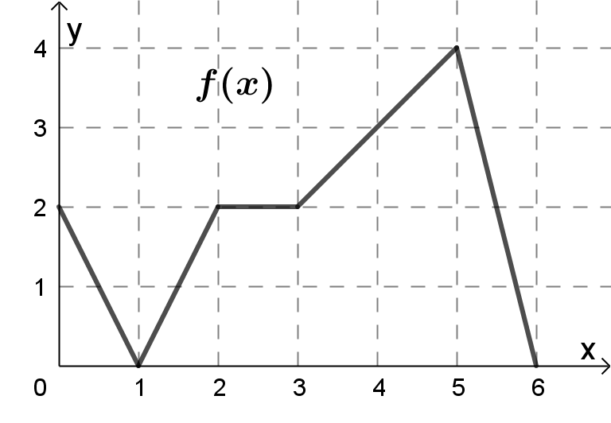  6  1  2 | 2

Vraag / Question 2 [16 punte / marks]
NR. | ANTWOORD / ANSWER | PUNTE  MARKS
2.1(a) | $2x^{2}-yi^{123}$ $=2{\left(4+2i\right)}^{2}-i^{123}\left(1-3i\right)$  $=2\left(16+16i+4i^{2}\right)✔-i^{3}✔\left(1-3i\right)$  $=32+32i+8i^{2}-i^{3}+3i^{4}$  $=32+32i-8+i+3$ $✔$  $=27 ✔+33i$ $✔$  OF / OR  $2x^{2}-yi^{123}$ $=2{\left(4+2i\right)}^{2}-i^{123}\left(1-3i\right)$  $=2\left(16+16i+4i^{2}\right)✔-i^{123}+3i^{124}$  $=32+32i+8i^{2}-i^{3}+3i^{4} ✔$  $=32+32i-8+i+3$ $✔$  $=27 ✔+33i$ $✔$ | 5
2.1(b) | Im$\left(3\left(1+3i\right) ✔\right)=$ Im$\left(3+9i\right)$ $=9 ✔$ | 2
2.2 | $$a+bi=\frac{1+3i}{1+i}×\frac{1-i}{1-i} ✔$$  $$=\frac{1-i+3i-3i^{2}}{1-i^{2}} ✔$$  $$=\frac{4+2i}{2} ✔$$  $$=2+i$$  $a=2 ✔$ en / and $b=1$ $✔$  OF / OR  $$1+3i=a+bi^{2}+ai+bi ✔$$  $=\left(a-b\right)+\left(a+b\right)i ✔$  $∴a-b=1$ en / and $a+b=3$ $✔$  Los gelyktydig op / Solve simultaneously, thus $a=2 ✔$ en / and $b=1$ $✔$ | 5
2.3 | $$\left(4-3i\right)\left(m+2i\right)$$  $$=4m+8i-3mi-6i^{2} ✔$$  $$=\left(4m+6\right)+i\left(8-3m\right) ✔$$  Suiwer imaginêr dus reële deel $=0$ / Pure imaginary thus real part $=0$:  $$4m+6=0 ✔ ⟹m=-\frac{6}{4}=-\frac{3}{2} ✔$$ | 4

Vraag / Question 3 [16 punte / marks]
NR. | ANTWOORD / ANSWER | PUNTE  MARKS
3.1 | $$\frac{5x^{2}+6x+7}{{\left(x+2\right)}^{2}(x-1)}≡\frac{A}{\left(x+2\right)}+\frac{B}{{\left(x+2\right)}^{2}} ✔+\frac{C}{x-1} ✔$$  $$5x^{2}+6x+7≡A\left(x+2\right)\left(x-1\right)+B\left(x-1\right)+C{\left(x+2\right)}^{2} ✔$$  Stel / Let $x=-2$: $15=-3B ⟹ B=-5 ✔$  Stel / Let $x=1$: $18=9C ⟹ C=2 ✔$  Stel / Let $x=0$: $7=-2A-B+4C ✔$  $7=-2A-\left(-5\right)+4\left(2\right)⟹ A=3 ✔$  $$∴\frac{5x^{2}+6x+7}{{\left(x+2\right)}^{2}\left(x-1\right)}≡\frac{3}{\left(x+2\right)}-\frac{5}{{\left(x+2\right)}^{2}}+\frac{2}{x-1} ✔$$ | 8
3.2(a) | $$g\left(x\right)=x^{2} ✔✔$$ | 2
3.2(b) | $$h\left(4\right)=\sqrt{3{\left(4\right)}^{2}+1} ✔=\sqrt{49}=7 ✔$$ | 2
3.2(c) | $$h\left(x\right)={\left(3x^{2}+1\right)}^{\frac{1}{2}} ✔$$  $$h^{'}\left(x\right)=\frac{1}{2}✔{\left(3x^{2}+1\right)}^{-\frac{1}{2}}✔(6x)✔$$ | 4

Vraag / Question 4 [14 punte / marks]
NR. | ANTWOORD / ANSWER | PUNTE  MARKS
4.1 | DIAGRAMBLAD / DIAGRAM SHEET 1  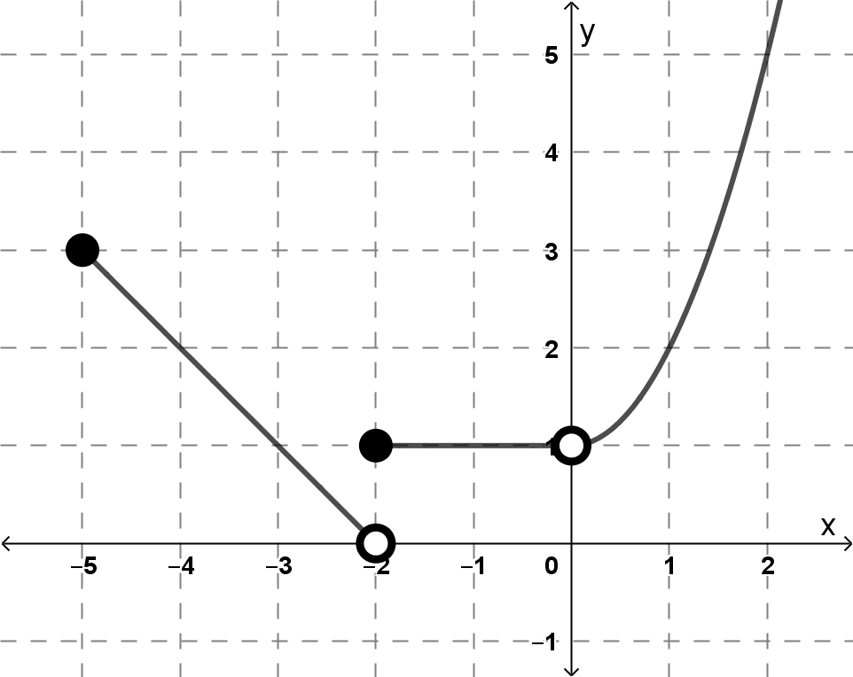  TOE kol / CLOSED dot (-5;3) $✔$  OOP kol / OPEN dot (-2;0) en / and TOE kol / CLOSED dot (-2;1) $✔$  Reguitlyn tussen / Straight line between $x∈\left[-5;2\right)$ $✔$  Horisontale lyn tussen / Horizontal line between $x∈\left[-2;0\right)$ $✔$  OOP kol / OPEN dot (0;1) $✔$  Parabool vir / Parabola for $x∈\left(0;∞\right)$ $✔$ | 6
4.2 | $$\tan{x}=\frac{1}{2} ⟹ x=\arctan{\frac{1}{2}}= 0.46 ✔$$ | 1
4.3(a) | $s=rθ$  $$2π=x\left(\frac{π}{2}\right)✔$$  $x=4$ $✔$ | 2
4.3(b) | Laat $x=5$:  Area van / of $∆$ABC $=\frac{1}{2}\left(5+3\right)\left(5+10\right) ✔=60$ $✔$ cm²  Area van sektor / of sector DBE $=\frac{1}{2}{\left(5\right)}^{2}\left(\frac{π}{2}\right)✔=\frac{25π}{4}=19.63…$ $✔$ cm²  Area van gearseerde deel is / Area of shaded part is:  $60-\frac{25π}{4}=40,365…≈40,37$ $✔$ cm² | 5

Vraag / Question 5 [16 punte / marks]
NR. | ANTWOORD / ANSWER | PUNTE  MARKS
5.1 | $$\tan{θ}=\frac{\frac{3}{2}}{2}=\frac{3}{4} ✔✔$$  $θ=0,64$ rad $✔$ | 3
5.2 (a) | $\left|a\right|=\sqrt{6^{2}+8^{2}}✔=10$ $✔$  $\left|b\right|=\sqrt{3^{2}+4^{2}}✔=5$ $✔$ | 4
5.2 (b) | $a ∙b=\left(-6\right)\left(3\right)+\left(8\right)\left(4\right)=14$ $✔✔$  $$a∙b=\left|a\right|\left|b\right|\cos{θ}$$  $14=\left(10\right)\left(5\right)\cos{θ} ✔$  $$\cos{θ}=\frac{14}{50} ✔$$  $θ=1.29$ rad $✔$ | 5
5.3 | $\left|u\right|=\sqrt{3^{2}+4^{2}}=5$ (vanuit vraag / from 5.2 (a))  Eenheidsvektor / Unit vector is $\frac{1}{5}✔\left(3;4\right)=\left(\frac{3}{5};\frac{4}{5}\right) ✔$ | 2
5.4 | $$(4 ✔;3 ✔)$$ | 2

Vraag / Question 6 [16 punte / marks]
NR. | ANTWOORD / ANSWER | PUNTE  MARKS
6.1(a) | $${\text{R}}^{\text{T}}✔=\left(\begin{matrix}-1 & -1 & 10 \\ -5 & 4 & 7\end{matrix}\right) ✔$$ | 2
6.1(b) | (i) M $+$ N $=\left(\begin{matrix}1 & 0 \\ 3 & 1\end{matrix}\right)+\left(\begin{matrix}-2 & 3 \\ 4 & 0\end{matrix}\right)=\left(\begin{matrix}-1 & 3 \\ 7 & 1\end{matrix}\right) ✔✔$  (ii) $\text{PQ}=\left(\begin{matrix}1 \\ 3\end{matrix}\right)\left(\begin{matrix}4 & -1\end{matrix}\right)=\left(\begin{matrix}4 & -1 \\ 12 & -3\end{matrix}\right) ✔✔$ | 2  2
6.2(a) | Enige een van die volgende vergelykings / Any one of the following equations:  $3x-y+z=2$  $$2x+y-4z=-13$$  $x-y-2z=-2$ $✔✔$ | 2
6.2(b) | $$\left|A\right|=\left|\begin{matrix}3 & -1 & 1 \\ 2 & 1 & -4 \\ 1 & -1 & -2\end{matrix}\right|=3\left|\begin{matrix}1 & -4 \\ -1 & -2\end{matrix}\right|+1\left|\begin{matrix}2 & -4 \\ 1 & -2\end{matrix}\right|+1\left|\begin{matrix}2 & 1 \\ 1 & -1\end{matrix}\right|✔$$  $=3\left(-2-4\right)+\left(-4+4\right)+\left(-2-1\right) ✔$  $=-21 ✔$  $$\left|A_{y}\right|=\left|\begin{matrix}3 & 2 & 1 \\ 2 & -13 & -4 \\ 1 & -2 & -2\end{matrix}\right|=3\left|\begin{matrix}-13 & -4 \\ -2 & -2\end{matrix}\right|-2\left|\begin{matrix}2 & -4 \\ 1 & -2\end{matrix}\right|+1\left|\begin{matrix}2 & -13 \\ 1 & -2\end{matrix}\right| ✔$$  $=3\left(26-8\right)-2\left(-4+4\right)+1\left(-4+13\right) ✔$  $=63 ✔$  $$∴y=\frac{\left|A_{y}\right|}{\left|A\right|}=\frac{63}{-21}✔=-3 ✔$$ | 8

Vraag / Question 7 [13 punte / marks]
NR. | ANTWOORD / ANSWER | PUNTE  MARKS
7.1 (a) | $$f\left(x\right)=5x^{\frac{1}{3}}-6x^{-2}+10$$  $$f^{'}\left(x\right)=\frac{5}{3}✔ x^{-\frac{2}{3}} ✔+12✔ x^{-3} ✔$$ | 4
7.1 (b) | $$\int{5x^{4}}+2x^{\frac{1}{2}}+1 dx$$  $$=x^{5} ✔+2×\frac{2}{3}✔ x^{\frac{3}{2}} ✔+x ✔+k$$ | 4
7.2 | $$f\left(x\right)=\int{f^{'}\left(x\right)} dx$$  $$=\int{{\left(2x+1\right)}^{5}} dx$$  $$=\frac{{\left(2x+1\right)}^{6} ✔}{6×2 ✔}+k=\frac{1}{12}{\left(2x+1\right)}^{6}+k$$  $$f\left(0\right)=\frac{1}{12}{\left(2\left(0\right)+1\right)}^{6}+k=1 ✔⟹ k=\frac{11}{12} ✔$$  $$f\left(x\right)=\frac{1}{12}{\left(2x+1\right)}^{6}+\frac{11}{12} ✔$$ | 5

Vraag / Question 8 [19 punte / marks]
NR. | ANTWOORD / ANSWER | PUNTE  MARKS
8.1 | Bepaal eers die snypunt / Firstly determine the intersection:  ${\left(x-2\right)}^{2}=-2x+7 ✔$  $x^{2}-4x+4=-2x+7$  $x^{2}-2x-3=0$  $\left(x-3\right)\left(x+1\right)=0$  $x=3 ✔$ of / or $x=-1 ✔$  Bereken nou die oppervlakte / Now, determine the area:  $$\int_{-1}^{ 3}{-2x+7-{\left(x-2\right)}^{2}} dx ✔$$  $$={\left[-x^{2} ✔+7x ✔-\frac{1}{3}{\left(x-2\right)}^{3} ✔\right]}_{-1}^{ 3}$$  $$=\left[-{\left(3\right)}^{2}+7\left(3\right)-\frac{1}{3}{\left(3-2\right)}^{3}\right] ✔-\left[-{\left(-1\right)}^{2}+7\left(-1\right)-\frac{1}{3}{\left(-1-2\right)}^{3}\right] ✔$$  $$=\frac{32}{3}=10\frac{2}{3} ✔$$  OF / OR  $$\int_{-1}^{ 3}{-2x+7-{\left(x-2\right)}^{2}} dx ✔$$  $$=\int_{-1}^{3}{-x^{2}+2x+3} dx ✔$$  $$={\left[-{\frac{1}{3}x}^{3}✔+x^{2}+3x ✔\right]}_{-1}^{ 3}$$  $$=\left[-\frac{1}{3}{\left(3\right)}^{3}+{\left(3\right)}^{2}+3(3)\right] ✔-\left[-\frac{1}{3}{\left(-1\right)}^{3}+{\left(-1\right)}^{2}+3(-1)\right] ✔$$  $$=\frac{32}{3}=10\frac{2}{3} ✔$$ | 10

NR. | ANTWOORD / ANSWER | PUNTE  MARKS
8.2 | $$π\int_{0}^{1}{{\left(1+ax\right)}^{2}}=\frac{1}{3}π ✔$$  $$\int_{0}^{1}{1+2ax+a^{2}x^{2}} dx ✔=\frac{1}{3}$$  $${\left.x ✔+ax^{2} ✔+\frac{1}{3}a^{2}x^{3} ✔\right|}_{0}^{1}=\frac{1}{3}$$  $$1+a{\left(1\right)}^{2}+\frac{1}{3}a^{2}{\left(1\right)}^{3}-0 ✔=\frac{1}{3}$$  $$\frac{1}{3}a^{2}+a+\frac{2}{3}=0$$  $a^{2}+3a+2=0 ✔$  $\left(a+1\right)\left(a+2\right)=0$  $a=-1$ $✔$of / or $a=-2$ $✔$  OF / OR  (Hierdie is ‘n ander moontlike oplossing, maar dit gaan moeilike algebra berekeninge wees / This is another possible answer, but it will lead to difficult algebra calculations)  $$π\int_{0}^{1}{{\left(1+ax\right)}^{2}}=\frac{1}{3}π ✔$$  $${\left.\frac{{\left(1+ax\right)}^{3}✔}{\left(3\right)✔×a ✔}\right|}_{0}^{1}=\frac{1}{3}$$  $$\frac{{\left(1+a\left(1\right)\right)}^{3}}{3a}-\frac{{\left(1+a\left(0\right)\right)}^{3}}{3a}✔=\frac{1}{3} ; a≠0$$  $$\frac{1}{3a}\left(1+3a+3a^{2}+a^{3}\right) ✔-\frac{1}{3a}=\frac{1}{3}$$  $a^{3}+3a^{2}+3a+1-1=a$  $a^{3}+3a^{2}+2a=0 ✔$  $a\left(a^{2}+3a+2\right)=0$  $a\left(a+2\right)\left(a+1\right)=0$  $a≠0$ of / or $a=-2 ✔$ of / or $a=-1$ $✔$ | 9

- EINDE VAN DIE MEMORANDUM / END OF THE MEMORANDUM -

