α-MATHEMATICS

Alpha Mathematics

Final examination 2018

Grade 10 Time: 2 hours
Examiner: H. Botha Total: 130 marks
Moderator: R. Grobler

INSTRUCTIONS AND INFORMATION
Carefully read through the following instructions before answering the question paper:
- This question paper consists of 7 pages, a formula sheet of 1 page and a diagram sheet of 2 pages.
- Answer ALL 8 questions.
- Number the answers exactly the way the questions are numbered.
- Non-programmable calculators may be used, unless otherwise indicated in the question.
- Unless indicated otherwise, all answers, where necessary, must be given correct to two decimal places
- Cleary show all calculations, diagrams, graphs et cetera that you have used in determining the answers.
- Answers only will not necessarily be awarded full marks.
- The diagrams in the question paper are not necessarily drawn to scale.
- All angles are given in radians. Answers must also be given in radians if necessary.
- Write neat and legible.

Question 1 [20 marks]
This question must be answered on the answer sheet.
Every question has ONLY one correct answer and is worth two (2) marks. Mark the correct answer with an X on the answer sheet.

1.1 What is the value of $k∈R$ so that $k\left(4-i\right)\left(4+i\right)$ will be pure imaginary?
(A) $k=0$
(B) $k=16$
(C) $k=17$
(D) No value for $k$.

1.2 Convert $65°$ to radians.
(A) $\frac{13}{35}π$ rad
(B) 1.13 rad
(C) 0.57 rad
(D) 3724.22 rad

1.3 If $F\left(x\right)=\left(f∘g\right)\left(x\right)=\sqrt{x^{2}+1}+{\left(x^{2}+1\right)}^{2}$, then $f(x)$ and $g\left(x\right)$ is equal to...
(A) $f\left(x\right)=\sqrt{x}+x$ and $g\left(x\right)={\left(x^{2}+1\right)}^{2}$
(B) $f\left(x\right)=\sqrt{x}+x$ and $g\left(x\right)=x^{2}+1$
(C) $f\left(x\right)=\sqrt{x}+x^{2}$ and $g\left(x\right)={\left(x^{2}+1\right)}^{2}$
(D) $f\left(x\right)=\sqrt{x}+x^{2}$ and $g\left(x\right)=x^{2}+1$

1.4 Simplify: $\left[\begin{matrix}1 & -1 & 2\end{matrix}\right]\left[\begin{matrix}0 \\ -2 \\ 3\end{matrix}\right]=$
(A) $[8]$
(B) $\left[\begin{matrix}0 & 2 & 6\end{matrix}\right]$
(C) $\left[\begin{matrix}0 \\ 2 \\ 6\end{matrix}\right]$
(D) $\left[4\right]$

1.5 Given the matrix: $\text{A}=\left[\begin{matrix}-1 & 2 \\ 2 & -1 \\ 0 & 3\end{matrix}\right]$.
Which one of the following options is not true:
(A) The determinant of A cannot be calculated.
(B) The dimension of A is $\left(3×2\right)$.
(C) ${\text{A}}^{\text{T}}=\left[\begin{matrix}-1 & 2 & 3 \\ 2 & -1 & 0\end{matrix}\right]$
(D) $\text{A}×{\text{A}}^{\text{T}}$ is a matrix with order of 3.

1.6 Which one of the following vectors is perpendicular on one another?
(A) $a=(3;4)$ and $b=\left(8;-6\right)$
(B) $a=(-3;4)$ and $b=\left(-8;6\right)$
(C) $a=\left(3;4\right)$ and $b=\left(-8;-6\right)$
(D) $a=(-3;-4)$ and $b=\left(-8;-6\right)$

1.7 Which one of the following vectors is equal to $-u$?
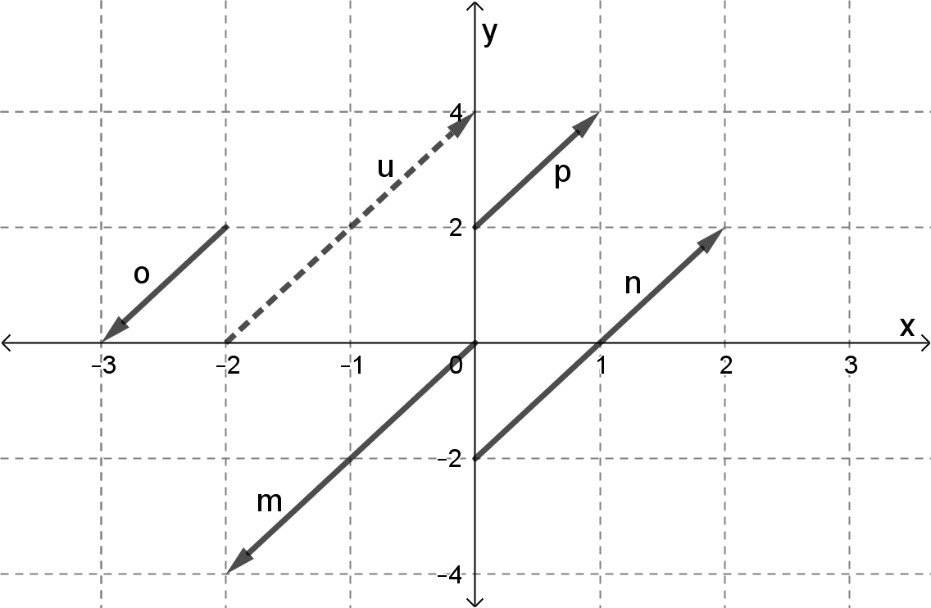
(A) n
(B) m
(C) p
(D) o

1.8 $\int_{0}^{m}{\frac{2}{\sqrt[3]{x^{2}}}}$ $dx=$
(A) $6\sqrt[3]{m}$
(B) $-\frac{6}{5} \sqrt[5]{m^{3}}$
(C) $\frac{1}{3}\sqrt[3]{m}$
(D) $6m^{3}$

1.9 The area enclosed by the function $y=2x$ between the $x$-axis and $x∈\left[-3;3\right]$ is...
(A) $0$
(B) $9$
(C) $18$
(D) $36$

1.10 If $f\left(x\right)=x^{3}$, $g\left(x\right)=1-2x$ and $y=\left(f∘g\right)\left(x\right)$, then $\frac{dy}{dx}$ $=$
(A) $3{\left(1-2x\right)}^{2}$
(B) $-6{\left(1-2x\right)}^{2}$
(C) $-6x^{2}$
(D) $-\frac{1}{8}{\left(1-2x\right)}^{3}$

Question 2 [17 marks]
2.1 Simplify and leave the answer in the form $a+bi$ with $a,b∈R$:
(a) $\left(1-4i\right)\left(2-i\right)$. (3)
(b) $4i^{3}+2i^{18}$ (3)
2.2 Determine integers $a$ and $b$ in $\left(1-i\right)\left(a+bi\right)=6+5i$. (6)
2.3 Sketch $\left(3-2i\right)+\left(-1-5i\right)$ graphically on an axes.
Use DIAGRAM SHEET 1 for the sketch. (4)
2.4 Give the conjugate of $\sqrt{5}i-10$? (1)

Question 3 [10 marks]
Decompose $\frac{2x^{2}+x}{{\left(x+1\right)}^{3}}$ into partial fractions.

Question 4 [15 marks]
4.1 Given: $f\left(x\right)={\left(\sqrt{x}+x\right)}^{3}$ and $g\left(x\right)=x^{2}$. Determine:
(a) $g\left(-1\right)$ (1)
(b) $\left(f∘g\right)\left(-1\right)$ (3)
4.2 Sketch the followings piecewise function for $x∈R$:
$$f(x)=\left\{\begin{matrix}x^{2} & \text{if} & x≤0 \\ x & \text{if} & 0<x<1 \\ 2 & \text{if} & x=1 \\ 4-x & \text{if} & x>1\end{matrix}\right.$$
Use DIAGRAM SHEET 2 for the sketch. (6)
4.3 A circle’s arc has a length of 75 cm spanned by the centre of the circle with an angle of $θ$ radians. The circle has a circumference of 200 cm. Calculate $θ$ in radians and leave the answer in terms of $π$. (5)

Question 5 [12 marks]
5.1 Given the system of equations $\left\{\begin{matrix}2x-y+z=6 \\ x+2y+4z=7 \\ 4x-2y+3z=15\end{matrix}\right.$ and $\left|\begin{matrix}2 & -1 & 1 \\ 1 & 2 & 4 \\ 4 & -2 & 3\end{matrix}\right|=5$.
Solve for $z$ in the above system of equations by using matrices and Cramer’s rule.
Clearly show the matrices you use to calculate the determinants. Do not write down only the answer of a determinant. Show ALL steps to support your answer. (6)

5.2 Solve for $x$ and $y$ in:
(a) $\left[\begin{matrix}8 & 11 \\ 6 & -7\end{matrix}\right]+\left[\begin{matrix}-9 & -16 \\ 22 & y\end{matrix}\right]=\left[\begin{matrix}-1 & x \\ 28 & 24\end{matrix}\right]$ (2)
(b) $\left[\begin{matrix}2x & 1 \\ x & y\end{matrix}\right]\left[\begin{matrix}1 & -1 \\ 2x & 9\end{matrix}\right]=\left[\begin{matrix}4 & 7 \\ -7 & -37\end{matrix}\right]$ (4)

Question 6 [15 marks]
6.1 Determine the unit vector of $a=\left(-6;8\right)$. (3)
6.2 Given $a=\left(-6;8\right)$, $b=\left(3;5\right)$ and $c=(-3;2)$.
Determine and simplify: $a+3\left(b-c\right)$. (4)
6.3 In the diagram, vector $u=\left(3;4\right)$ and $v=\left(2;-1\right)$ are sketched. $θ$ is the angle between vector $u$ and $v$.
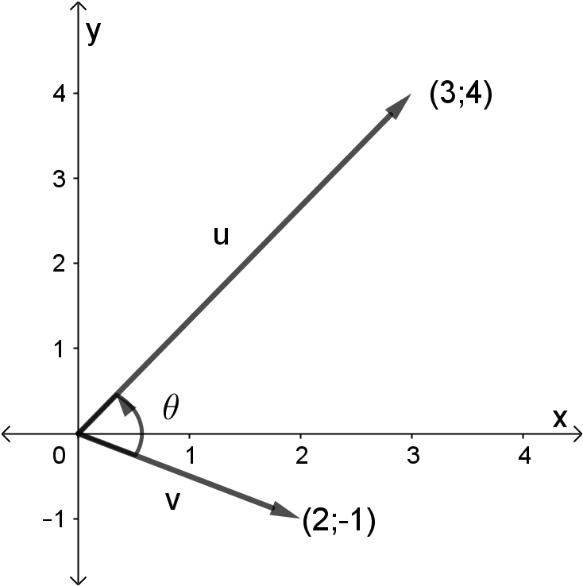
(a) Determine the size of vector $u$ and $v$. (4)
(b) Calculate the size of $θ$ in radians. (4)

Question 7 [15 marks]
7.1 Given: $f\left(x\right)=-x^{2}+5x-7$.
(a) Determine $f^{'}\left(x\right)$. (2)
(b) Hence, determine the gradient of the tangent to $f$ in the point $\left(1;-3\right)$. (2)
7.2 Differentiate the following function. It is not necessary to simplify the answers.
(a) $f\left(x\right)=\sqrt{x^{3}}+$ $\frac{5}{x^{2}}$ $+π+x^{-1}$ (4)
(b) $g(m)=m^{3}\left(4m^{2}-5\right)$ (3)
(c) $y=$ $\frac{1}{\sqrt[5]{1-5x+x^{2}}}$ (4)

Question 8 [26 marks]
8.1 Determine the following integral. $\int{\sqrt{x}+x^{-2}+x^{5}+1} dx$
It is not necessary to simplify the answers. (4)
8.2 Given $f'\left(x\right)=x+$ $\frac{1}{x^{4}}$ $+ 1$, the derivative of $f(x)$.
Determine the equation of $f\left(x\right)$ if $f$ passes through the point $\left(1 ;\frac{5}{3}\right)$. (5)
8.3 The function $f\left(x\right)=\sqrt{16-2x}$ and $g\left(x\right)=m$ (horisontal line) are sketched below.
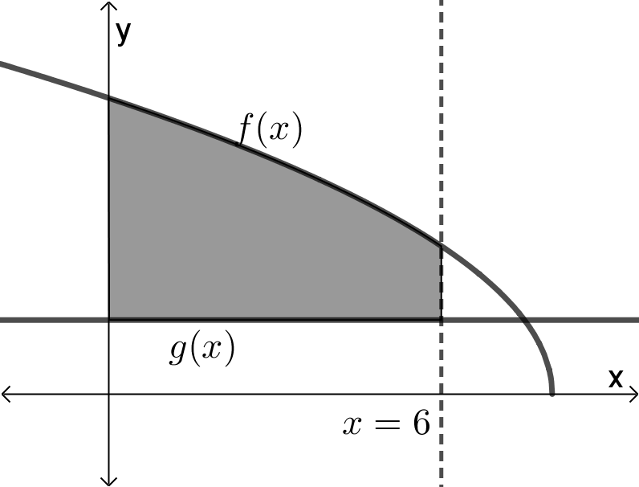
(a) The area of the shaded region, between $x=0$ and $x=6$, is $12\frac{2}{3}$.
Determine the value of $m$. (11)
(b) The volume of revolution that exists if $f\left(x\right)$ rotates about the $x$-axis
between $x=0$ and $x=p$ is $28π$.
Determine the value of $p$ if $p∈\left(0;8\right)$. (6)
- END OF THE QUESTION PAPER -

ALPHA MATHEMATICS FORMULA SHEET

MATRICES AND VECTORS:
$$\text{Cramer}\text{'s rule}\text{:} x_{i}=\frac{\left|A_{i}\right|}{\left|A\right|}$$
$$a∙b=\left|a\right|\left|b\right|\cos{θ}$$
$$a∙b=a_{x}b_{x}+a_{y}b_{y}$$

CALCULUS:
$$V=π\int_{a}^{b}{{\left[f\left(x\right)\right]}^{2} dx}$$ | $$\int_{a}^{b}{x^{n} dx={\left[\frac{x^{n+1}}{n+1}\right]}_{a}^{b}}$$

TRIGONOMETRY:
In a sector: $s=rθ$ and $A=\frac{1}{2}r^{2}θ$

TABLES WITH DERIVATIVES:
$$F(x)$$ | $$F^{'}\left(x\right)$$
$$ax^{n}$$ | $$nax^{n-1}$$
$$f\left[g\left(x\right)\right]$$ | $$f^{'}\left[g\left(x\right)\right].g^{'}\left(x\right)$$

Alpha Mathematics Grade 10 - Final examination 2018

ANSWER SHEET

Name and Surname: ______________________________________________________

Question  Total | 1  [20] | 2  [17] | 3  [10] | 4  [15] | 5  [12] | 6  [15] | 7  [15] | 8  [26] |  | TOTAL  130
Student mark

Question 1

1.1 | A | B | C | D
1.2 | A | B | C | D
1.3 | A | B | C | D
1.4 | A | B | C | D
1.5 | A | B | C | D
1.6 | A | B | C | D
1.7 | A | B | C | D
1.8 | A | B | C | D
1.9 | A | B | C | D
1.10 | A | B | C | D

DIAGRAM SHEET 1 [Question 2.3]
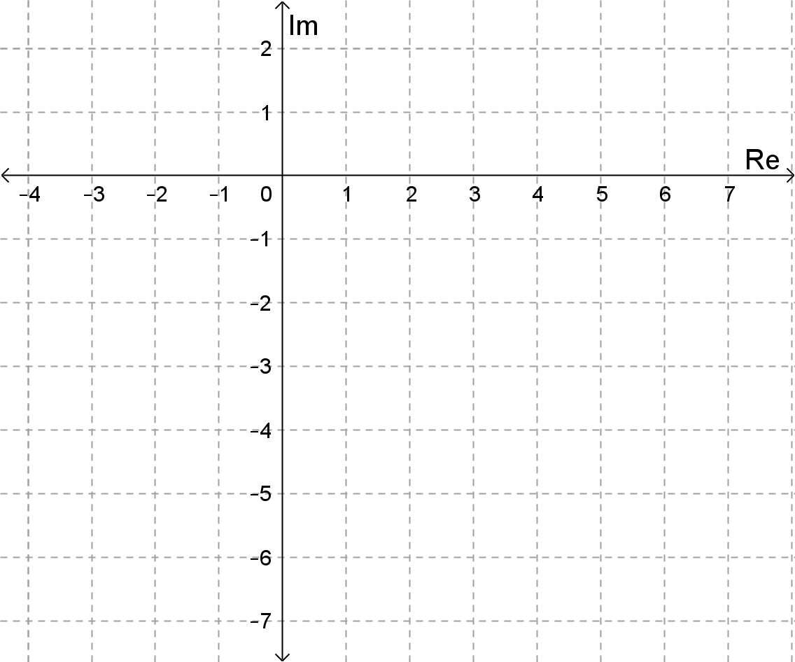

DIAGRAM SHEET 2 [Question 4.2]


