α-WISKUNDE

Alpha Wiskunde Graad 10 / Alpha Mathematics Grade 10
Finale eksamen 2018 / Final examination 2018

MEMORANDUM

Totaal / Total: 130 punte / marks

Eksaminator / Examiner: Hennie Botha
Moderator: Rika Grobler

Hierdie memorandum bestaan uit 12 bladsye. /
This memorandum consists of 12 pages.

Vraag / Question 1 [20 punte / marks]

1.1 | A | B | C | D
1.2 | A | B | C | D
1.3 | A | B | C | D
1.4 | A | B | C | D
1.5 | A | B | C | D
1.6 | A | B | C | D
1.7 | A | B | C | D
1.8 | A | B | C | D
1.9 | A | B | C | D
1.10 | A | B | C | D

NR.  NO | ANTWOORD ANSWER | BEREKENINGE (nie vir nasien doeleindes nie)  CALCULATIONS (not for marking purpose) | PUNTE MARKS
1.1 | D | $$k\left(4-i\right)\left(4+i\right)=k\left(16-i^{2}\right) \\ =k\left(16+1\right) \\ =17k \text{is altyd suiwer reëel.}$$  $∴$ Geen waarde vir $k.$ | 2
1.2 | B | $$65°×\frac{π}{180°}=1.13 \text{rad}$$ | 2
1.3 | D | (A) $f\left(x\right)=\sqrt{x}+x$ en $g\left(x\right)={\left(x^{2}+1\right)}^{2}$  Dan is: $\left(f∘g\right)\left(x\right)=\sqrt{{\left(x^{2}+1\right)}^{2}}+{\left(x^{2}+1\right)}^{2}≠F\left(x\right)$  (B) $f\left(x\right)=\sqrt{x}+x$ en $g\left(x\right)=x^{2}+1$  Dan is: $\left(f∘g\right)\left(x\right)=\sqrt{x^{2}+1}+\left(x^{2}+1\right)≠F\left(x\right)$  (C) $f\left(x\right)=\sqrt{x}+x^{2}$ en $g\left(x\right)={\left(x^{2}+1\right)}^{2}$  Dan is: $\left(f∘g\right)\left(x\right)=\sqrt{{\left(x^{2}+1\right)}^{2}}+{\left(x^{2}+1\right)}^{4}≠F\left(x\right)$  (D) $f\left(x\right)=\sqrt{x}+x^{2}$ en $g\left(x\right)=x^{2}+1$  Dan is: $\left(f∘g\right)\left(x\right)=\sqrt{x^{2}+1}+{\left(x^{2}+1\right)}^{2}=F\left(x\right)$ | 2
1.4 | A | $$\left[\begin{matrix}1 & -1 & 2\end{matrix}\right]\left[\begin{matrix}0 \\ -2 \\ 3\end{matrix}\right]=\left[0+2+6\right]=[8]$$ | 2
1.5 | C | (A) Waar, want die matriks moet ‘n vierkantige matriks wees.  (B) Waar  (C) Nie waar nie, moet wees: ${\text{A}}^{\text{T}}=\left[\begin{matrix}-1 & 2 & 0 \\ 2 & -1 & 3\end{matrix}\right]$  (D) Waar. $\left(3×2\right)×\left(2×3\right)=\left(3×3\right)$ | 2
1.6 | A | (A) $a b=3×8+4\left(-6\right)=0$  (B) $a b=\left(-3\right)\left(-8\right)+4×6=48$  (C) $a b=3\left(-8\right)+4\left(-6\right)=-48$  (D) $a b=\left(-3\right)\left(-8\right)+(-4)\left(-6\right)=48$ | 2
1.7 | B | Ewewydig aan $u$, maar in teenoorgestelde rigting as $u$ en dieselfde grootte, dus $m$. | 2
1.8 | A | $$\int_{0}^{m}{2x^{-\frac{2}{3}}} dx={\left[6x^{\frac{1}{3}}\right]}_{0}^{m}=6m^{\frac{1}{3}}=6\sqrt[3]{m}$$ | 2
1.9 | C | $$\int_{0}^{3}{2x} dx={\left[x^{2}\right]}_{0}^{3}=3^{2}-0=9$$  Oppervlakte is $9×2=18$ | 2
1.10 | B | $$y=\left(f∘g\right)\left(x\right) \\ =f\left(g\left(x\right)\right) \\ =f(1-2x) \\ ={\left(1-2x\right)}^{3} \\ \frac{dy}{dx}=-6{\left(1-2x\right)}^{2}$$ | 2

Vraag / Question 2 [17 punte / marks]
NR.  NO | ANTWOORD / ANSWER | PUNTE / MARKS
2.1 (a) | $$\left(1-4i\right)\left(2-i\right)=2-i-8i+4i^{2} \\ =2-9i-4 \\ =-2-9i$$ | - Vermenigvuldig korrek  - Antwoord $-2$  - Antwoord $-9i$  [3 punte / marks]
2.1 (b) | $$4i^{3}+2i^{18}$$  $$=-4i+2i^{2}$$  $$=-4i-2$$ | - $-i$  - $i^{2}$  - $-2$  [3 punte / marks]
2.2 | $$a+bi=\frac{6+5i}{1-i}×\frac{1+i}{1+i} \\ =\frac{6+6i+5i+5i^{2}}{1-i^{2}} \\ =\frac{1+11i}{2} \\ =\frac{1}{2}+\frac{11}{2}i$$  $$∴a=\frac{1}{2} \text{en} b=\frac{11}{2}$$ | - Vorm  - Toegevoegde term  - Vermenigvuldig teller  - Vermenigvuldig noemer  - Antwoord $a=\frac{1}{2}$  - Antwoord $b=\frac{11}{2}$  [6 punte / marks]
2.2 | OF / OR | OF / OR
2.2 | $$\left(1-i\right)\left(a+bi\right)=6+5i \\ a+bi-ai-bi^{2}=6+5i \\ \left(a+b\right)+\left(b-a\right)i=6+5i$$  $a+b=6$ of / or $b-a=5$  Gelyktydige oplossing:  $a=6-b$ $b-\left(6-b\right)=6$  $b-6+b=5$  $b=\frac{11}{2}$  Eliminasie: OF / OR  $$a+b=6 \\ \underline{-a+b=5 } \\ 2b=11 \\ b=\frac{11}{2}$$  Vervang $b$ in enige vergelyking om $a$ te bereken:  $$a+\frac{11}{2}=6 \text{of / }\text{or} \frac{11}{2}-a=5$$  $$∴a=\frac{1}{2}$$ | - Vermenigvuldig uit  - $a+b=6$  - $b-a=5$  - Metode  - Antwoord $b=\frac{11}{2}$  - Antwoord $a=\frac{11}{2}$  [6 punte / marks]
2.3 | 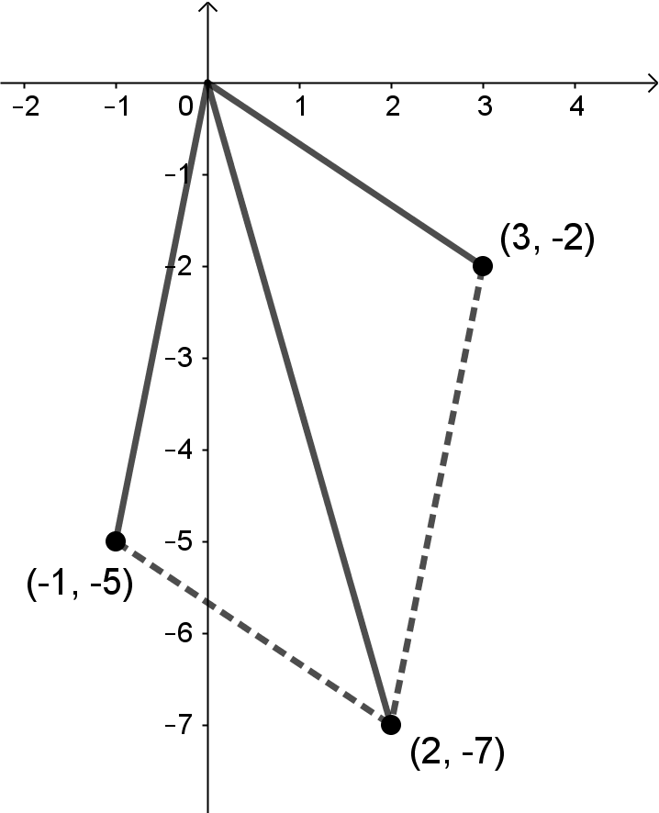 | - $-1-5i$  - $3-2i$  - $2-7i$  - Voltooi die parm  [4 punte / marks]
2.4 | Toegevoegde is $-\sqrt{5}i-10$. | - Antwoord  [1 punt / mark]

Vraag / Question 3 [10 punte / marks]
NR.  NO | ANTWOORD / ANSWER | PUNTE / MARKS
3 | $$\frac{2x^{2}+x}{{\left(x+1\right)}^{3}}≡\frac{A}{x+1}+\frac{B}{{\left(x+1\right)}^{2}}+\frac{C}{{\left(x+1\right)}^{3}}$$  $$2x^{2}+x≡A{\left(x+1\right)}^{2}+B\left(x+1\right)+C$$  Stel $x=-1$: $C=1$  $$≡Ax^{2}+2Ax+A+Bx+B+C \\ ≡x^{2}\left(A\right)+x\left(2A+B\right)+(A+B+C)$$  $∴A=2$  $$2A+B=1 \\ 2\left(2\right)+B=1 \\ ∴B=-3$$  $$∴\frac{2x^{2}+x}{{\left(x+1\right)}^{3}}≡\frac{2}{x+1}-\frac{3}{{\left(x+1\right)}^{2}}+\frac{1}{{\left(x+1\right)}^{3}}$$ | - Ontbind in parsiële breuke  - Vermenigvuldig met KGV  - ✔ Antwoord $C=1$  - Vereenvoudig  - Groepeer volgens magte van $x$  - Antwoord $A=2$  - Vergelyking van koëffisiënte van $x$’e  - Antwoord $B=-3$  - Finale antwoord  [10 punte / marks]
 | OF / OR | OF / OR
 | $$\frac{2x^{2}+x}{{\left(x+1\right)}^{3}}≡\frac{A}{x+1}+\frac{B}{{\left(x+1\right)}^{2}}+\frac{C}{{\left(x+1\right)}^{3}}$$  $$2x^{2}+x≡A{\left(x+1\right)}^{2}+B\left(x+1\right)+C \\ ≡Ax^{2}+2Ax+A+Bx+B+C \\ ≡x^{2}\left(A\right)+x\left(2A+B\right)+(A+B+C)$$  $∴A=2$  $$2A+B=1 \\ 2\left(2\right)+B=1 \\ ∴B=-3$$  $$A+B+C=0 \\ 2-3+C=0 \\ ∴C=1$$  $$∴\frac{2x^{2}+x}{{\left(x+1\right)}^{3}}≡\frac{2}{x+1}-\frac{3}{{\left(x+1\right)}^{2}}+\frac{1}{{\left(x+1\right)}^{3}}$$ | - Ontbind in parsiële breuke  - Vermenigvuldig met KGV  - Vereenvoudig  - Groepeer volgens magte van $x$  - Antwoord $A=2$  - Vergelyking van koëffisiënte van $x$’e  - Antwoord $B--3$  - Vergelyking van konstantes  - Antwoord $C=1$  - Finale antwoord  [10 punte / marks]

Vraag / Question 4 [15 punte / marks]
NR.  NO | ANTWOORD / ANSWER | PUNTE / MARKS
4.1 (a) | $$g\left(-1\right)={\left(-1\right)}^{2}=1$$ | - Antwoord  [1 punt / mark]
4.1 (b) | $$\left(f∘g\right)\left(-1\right)=f\left(g\left(-1\right)\right) \\ =f(1) \\ ={\left(\sqrt{1}+1\right)}^{3} \\ =2^{3} \\ =8$$ | - $f\left(g\left(-1\right)\right)$  - Vervang $1$ in $x$’e  - Antwoord  [3 punte / marks]
 | OF / OR | OF / OR
 | $$\left(f∘g\right)\left(x\right)=f\left(g\left(x\right)\right) \\ =f\left(x^{2}\right) \\ ={\left(\sqrt{x^{2}}+x^{2}\right)}^{3}$$  $$\left(f∘g\right)\left(-1\right)={\left(\sqrt{{(-1)}^{2}}+{\left(-1\right)}^{2}\right)}^{3} \\ ={\left(\sqrt{1}+1\right)}^{3} \\ =2^{3} \\ =8$$ | - $\left(f∘g\right)\left(x\right)$  - Vervang $-1$ in $e$’e  - Antwoord  [3 punte / marks]
4.2 | 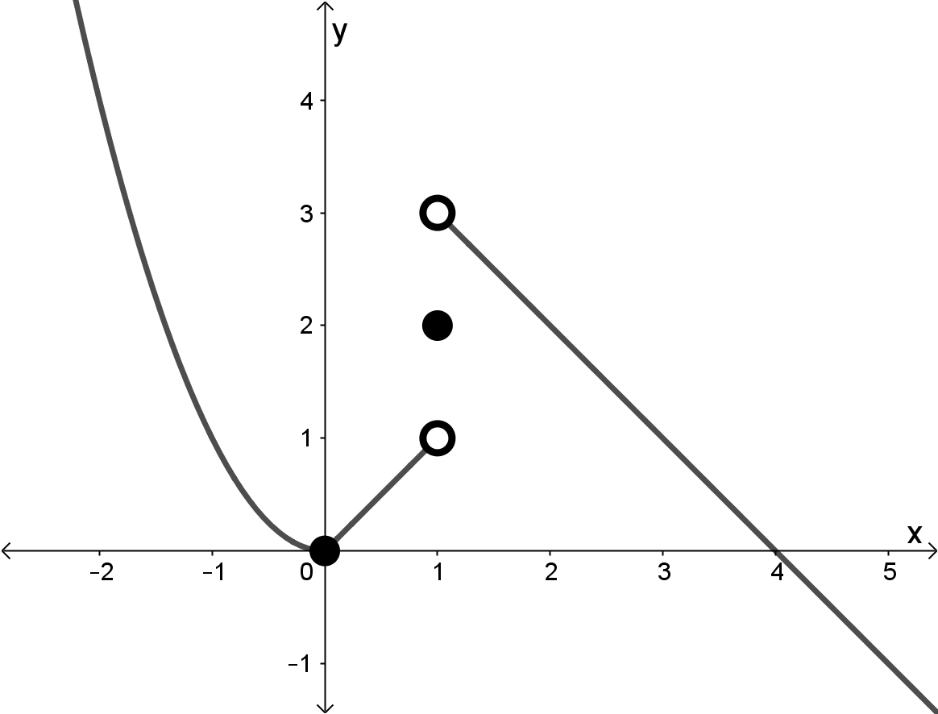 | - $y=x^{2}$  - $y=x$  - Oop kol by $\left(1;1\right)$  - Toe kol by $\left(1;2\right)$  - Oop kol by $\left(1;3\right)$  - $y=4-x$  $-1$ punt: indien OOP kol by die oorsprong.  [6 punte / marks]
4.3 | Omtrek van sirkel is 200 cm:  $$200=2πr \\ r=\frac{100}{π}$$  Booglengte is 75 cm:  $$75=rθ \\ θ=75÷\frac{100}{π} \\ =\frac{3π}{4} \text{rad}$$ | - Vergelyking (omtrek)  - $r$  - Vergelyking (booglengte)  - Vervang $r$ in vergelyking  - Antwoord (in terme van $π$)  [5 punte / marks]

Vraag / Question 5 [12 punte / marks]
NR.  NO | ANTWOORD / ANSWER |  |  | PUNTE / MARKS
5.1 | $$z=\frac{\det{A_{z}}}{\det{A}}$$  $$\det{A_{z}}= \left|\begin{matrix}2 & -1 & 6 \\ 1 & 2 & 7 \\ 4 & -2 & 15\end{matrix}\right| \\ =2\left|\begin{matrix}2 & 7 \\ -2 & 15\end{matrix}\right|+1\left|\begin{matrix}1 & 7 \\ 4 & 15\end{matrix}\right|+6\left|\begin{matrix}1 & 2 \\ 4 & -2\end{matrix}\right| \\ =2\left(30+14\right)+\left(15-28\right)+6(-2-8) \\ =15$$  $$∴z=\frac{15}{5}=3$$ |  |  | - Korrekte determinant  - ✔✔ Elke kofaktor term  - $15$  - Antwoord  [6 punte / marks]
5.2 (a) | $$11-16=x \\ x=-5$$  $$-7+y=24 \\ y=31$$ |  |  | - Antwoord van $x$  - Antwoord van $y$  [2 punte / marks]
5.2 (b) | $$2x+2x=4 \\ 4x=4 \\ x=1$$  $$x+2xy=-7 \\ 1+2y=-7 \\ y=-4$$ | OF / OR  OF / OR | $$-2x+9=7 \\ -2x=-2 \\ x=1$$  $$-x+9y=-37 \\ -1+9y=-37 \\ y=-4$$ | - Vergelyking om $x$ op te los  - Antwoord van $x$  - Vergelyking om $y$ op te los  - Antwoord van $y$  [4 punte / marks]

Vraag / Question 6 [15 punte / marks]
NR.  NO | ANTWOORD / ANSWER | PUNTE / MARKS
6.1 | $$\left|a\right|=\sqrt{6^{2}+8^{2}} \\ =10$$  Eenheidsvektor is:  $$\frac{a}{\left|a\right|}=\left(-\frac{6}{10};\frac{8}{10}\right) \\ =\left(-\frac{3}{5};\frac{4}{5}\right)$$ | - Grootte van $a$, |a|  - Metode om eenheidsvektor te bereken  - Antwoord (vereenvoudig of nie)  [3 punte / marks]
6.2 | $$\left(-6;8\right)+3\left(\left(3;5\right)-\left(-3;2\right)\right)$$  $$=\left(-6;8\right)+3\left(6;3\right)$$  $$=\left(-6;8\right)+\left(18;9\right)$$  $$=\left(12;17\right)$$ | - $\left(6;3\right)$  - $\left(18;9\right)$  - Antwoord $12$  - Antwoord $17$  [4 punte / marks]
6.3 (a) | $$\left|u\right|=\sqrt{3^{2}+4^{2}}=5$$  $$\left|v\right|=\sqrt{2^{2}+1^{2}}=\sqrt{5}$$ | - ✔ Antwoord $\left|u\right|$  - ✔ Antwoord $\left|v\right|$  [4 punte / marks]
6.3 (b) | $$u v=\left(3\right)\left(2\right)+\left(4\right)\left(-1\right)=2$$  $$u v=\left|u\right|\left|v\right|\cos{θ} \\ 2=5\sqrt{5}\cos{θ} \\ \cos{θ}=\frac{2}{5\sqrt{5}} \\ θ=1.39 \text{rad}$$ | - ✔ $u v=2$  - Vervang in formule  - Antwoord  [4 punte / marks]

Vraag / Question 7 [15 punte / marks]
NR.  NO | ANTWOORD / ANSWER | PUNTE / MARKS
7.1 (a) | $$f^{'}\left(x\right)=-2x+5$$ | - ✔ Differensieer elke term  [2 punte / marks]
7.1 (b) | $$f^{'}\left(1\right)=-2\left(1\right)+5=3$$  Gradiënt van $f$ in die punt $(1;-3)$ is 3. | - Vervang $x=1$ in $f^{'}\left(x\right)$  - Antwoord  [2 punte / marks]
7.2 (a) | $$f\left(x\right)=x^{\frac{3}{2}}+5x^{-2}+π+x^{-1}$$  $$f^{'}\left(x\right)=\frac{3}{2}x^{\frac{1}{2}}-10x^{-3}-x^{-2}$$ | - ✔✔ Differensieer elke term  - $π$ se afgeleide is nul  [4 punte / marks]
7.2 (b) | $$g\left(m\right)=4m^{5}-5m^{3}$$  $$g^{'}\left(m\right)=20m^{4}-15m^{2}$$ | - Vermenigvuldig hakies  - ✔ Differensieer elke term  [3 punte / marks]
7.2 (c) | $$y={\left(1-5x+x^{2}\right)}^{-\frac{1}{5}}$$  $$\frac{dy}{dx}=-\frac{1}{5}{\left(1-5x+x^{2}\right)}^{-\frac{6}{5}}\left(-5+2x\right)$$ | - $-\frac{1}{5}$  - ${\left(1-5x+x^{2}\right)}^{-\frac{6}{5}}$  - $-5$  - $2x$  [4 punte / marks]

Vraag / Question 8 [26 punte / marks]
NR.  NO | ANTWOORD / ANSWER | PUNTE / MARKS
8.1 | $$\int{x^{\frac{1}{2}}+x^{-2}+x^{5}+1} dx$$  $$=\frac{2}{3}x^{\frac{3}{2}}-x^{-1}+\frac{1}{6}x^{6}+x+k$$ | - ✔✔✔ Integreer elke term  [4 punte / marks]
8.2 | $$f\left(x\right)=\int{f^{'}\left(x\right)} dx \\ =\int{x^{-4}+1} dx \\ =-\frac{1}{3}x^{-3}+x+k$$  $$f\left(1\right)=\frac{5}{3} \\ \frac{5}{3}=-\frac{1}{3}{\left(1\right)}^{-3}+1+k \\ k=1$$  $$∴f\left(x\right)=-\frac{1}{3}x^{-3}+x+1=-\frac{1}{3x^{3}}+x+1$$ | - $∫f^{'}\left(x\right)dx$  - Integreer $f^{'}\left(x\right)$  - Vervang $\left(1;\frac{5}{3}\right)$ in  - $k=1$  - Antwoord - $f\left(x\right)$  [5 punte / marks]
8.3 (a) | $$\text{Area}=\int_{0}^{6}{f\left(x\right)-g\left(x\right)} dx \\ \frac{38}{3}=\int_{0}^{6}{{\left(16-2x\right)}^{\frac{1}{2}}-m} dx \\ \frac{38}{3}={\left[\frac{{\left(16-2x\right)}^{\frac{3}{2}}}{\frac{3}{2}×\left(-2\right)}-mx\right]}_{0}^{6} \\ \frac{38}{3}=\left[-\frac{1}{3}{\left(16-12\right)}^{\frac{3}{2}}-6m\right]-\left[-\frac{1}{3}{\left(16\right)}^{\frac{3}{2}}-0\right] \\ \frac{38}{3}=-\frac{1}{3}{\left(4\right)}^{\frac{3}{2}}-6m+\frac{1}{3}{\left(4\right)}^{\frac{6}{2}} \\ 38=-2^{\frac{6}{2}}-18m+2^{\frac{12}{2}} \\ m=1$$ | - $\frac{38}{3}=12\frac{2}{3}$  - Grense tussen $0$ en $6$  - Funksie: ${\left(16-2x\right)}^{\frac{1}{2}}-m$  - ${\left(16-2x\right)}^{\frac{3}{2}}$  - $\frac{3}{2}$ ✔ $\left(-2\right)$✔ $mx$  - ✔ Vervang grense in  - Vereenvoudig  - Antwoord  [11 punte / marks]

NR.  NO | ANTWOORD / ANSWER | PUNTE / MARKS
8.3 (b) | $$V=π\int_{0}^{p}{{\left(f\left(x\right)\right)}^{2}} dx \\ 28π=π\int_{0}^{p}{{\left(\sqrt{16-2x}\right)}^{2}} dx \\ 28=\int_{0}^{p}{16-2x} dx \\ 28={\left[16x-x^{2}\right]}_{0}^{p} \\ 28=16p-p^{2}-0 \\ 0=p^{2}-16p+28 \\ 0=\left(p-2\right)\left(p-14\right) \\ p=2$$ | - Vervang in formule  - Kwadreer uit  - Integreer  - Vervang grense in  - Faktoriseer  - Antwoord  Indien $p=14$ as antwoord ook, minus 1 punt.  [6 punte / marks]

- EINDE VAN DIE MEMORANDUM / END OF THE MEMORANDUM -

