α-MATHEMATICS

Alpha Mathematics

Final exam 2019

Grade 10 Time: 2 hours
Examiner: R Grobler Total: 130 marks
Moderator: A Muller

INSTRUCTIONS AND INFORMATION
Carefully read through the following instructions before answering the question paper:
- This question paper consists of 7 pages, a formula sheet of 1 page and a diagram sheet of 2 pages.
- Answer ALL 8 questions.
- Number the answers exactly the way the questions are numbered.
- Non-programmable calculators may be used, unless otherwise indicated in the question.
- Unless indicated otherwise, all answers, where necessary, must be given correct to two decimal places
- Cleary show all calculations, diagrams, graphs et cetera that you have used in determining the answers.
- Answers only will not necessarily be awarded full marks.
- The diagrams in the question paper are not necessarily drawn to scale.
- All angles are given in radians. Answers must also be given in radians if necessary.
- Write neat and legible.

Question 1 [20 marks]
This question must be answered on the answer sheet. Every question has ONLY one correct answer and is worth two (2) marks. Mark the correct answer with an X on the answer sheet.

1.1 What is the value of $k∈R$ so that $k\left(4-i\right)\left(4+i\right)$ will be only imaginary?
(A) $k=0$
(B) $k=16$
(C) $k=i$
(D) $k=i^{2}$

1.2 Convert $390°$ to radians.
(A) $\frac{13π}{12}$ rad
(B) $\frac{13π}{6}$ rad
(C) 0.57 rad
(D) 3724.22 rad

1.3 If $F(x)={\left(x^{2}-1\right)}^{3}-5(x^{2}-1)$and$F\left(x\right)=(f∘g)(x)$, then
(A) $f\left(x\right)=x^{3}-5x$ and $g\left(x\right)=x^{2}-1$
(B) $f\left(x\right)=x^{2}-1$ and $g\left(x\right)=x^{3}-5x$
(C) $f\left(x\right)=x^{2}$ and $g\left(x\right)=5(x-1)$
(D) $f\left(x\right)=5(x-1)$and$g\left(x\right)=x^{2}$

1.4 Simplify: : $\left(\begin{matrix}0 \\ -2 \\ 3\end{matrix}\right)×\left(\begin{matrix}1 & -1 & 2\end{matrix}\right)=$
(A) $\left(8\right)$
(B) $\left(\begin{matrix}0 & 2 & 6\end{matrix}\right)$
(C) $\left(\begin{matrix}0 & 0 & 0 \\ -2 & 2 & -4 \\ 3 & -3 & 6\end{matrix}\right)$
(D) Impossible

1.5 Which one of the following options is true?
(A) Matrices must have the same dimensions when they are multiplied.
(B) Matrices must have the same dimensions when they are added.
(C) The number $\sqrt{-1}$ is undefined.
(D) Two vectors are only equal if they have the same size and direction and start at the same point.

1.6 The angle between two vectors will be equal to $\frac{π}{2}$ if
(A) the point product of the vectors is equal to 0.
(B) the point product of the vectors is equal to $\frac{π}{2}$.
(C) the size of one of the vectors equal 0.
(D) none of the above. There is no rule for this.

1.7 Given $f\left(x\right)={\left(x-1\right)}^{6}$. then $f^{'}\left(3\right)=$
(A) 32
(B) $96$
(C) $\frac{96}{3}$
(D) $192$

1.8 $\int_{a}^{0}{2\sqrt{x}}$ $dx=$
(A) $\sqrt{a}$
(B) $-\frac{2}{3} {\sqrt{a}}^{3}$
(C) $\frac{1}{3}\sqrt[3]{a}$
(D) $-\frac{4}{3}\sqrt{a^{3}}$

1.9 The area that is included by the function $y=3x^{2}$ between the $x$-axis and
$x∈\left[-1;1\right]$ is...
(A) $0$
(B) $1$
(C) $2$
(D) $6$

1.10 The sketch shows a function $f$ as dots and function $g$ as crosses (x). The value
of $(f∘g)\left(1\right)=$
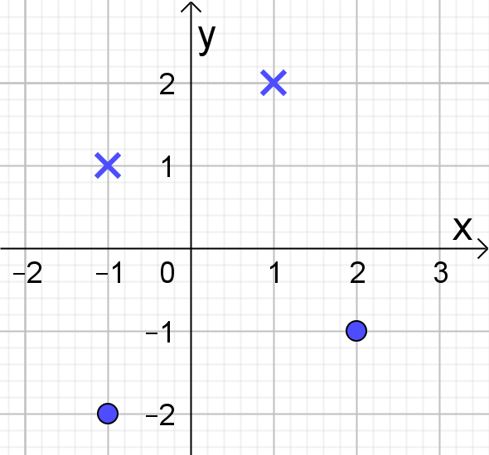
(A) $-2$ (B) $-1$ (C) $2$ (D) 1

Question 2 [16 marks]
2.1 Simplify and leave the answer in the form $a+bi$ with $a,b∈R$:
(a) $\left(2+6i\right)\left(1-4i\right)$. (3)
(b) $\frac{i^{181}}{1+i}$ (4)
2.2 Determine integers $m$and$n$ in $\left(m-i\right)\left(1+2i\right)=n+5i$. (6)
2.3 Represent $\left(-2-3i\right)+\left(7-2i\right)$ graphically on a set of axes.
Use DIAGRAM SHEET 1 for your sketch. (3)

Question 3 [11 marks]
Decompose $\frac{-2x^{2}-x+15}{{\left(x-1\right)}^{2}\left(x+2\right)}$ into partial fractions. (11)

Question 4 [17 marks]
4.1 $f\left(x\right)=\frac{1}{2-x}$and$g\left(x\right)=2+\sqrt{x}$, Determine $(g∘f)\left(-7\right)$. (4)
4.2 Sketch the following piecewise function for $-3≤x≤5$:
$$f(x)=\left\{\begin{matrix}1-x & \text{as} & x≤-1 \\ x^{2} & \text{as} & -1<x<1 \\ 2^{x} & \text{as} & x=1 \\ 2 & \text{as} & x>1\end{matrix}\right.$$
Use DIAGRAM SHEET 2 for your sketch. (6)
4.3 In the sketch is OAB and OCD radï of a circle with centre O and radius 10 cm. $A\hat{O}C=α$ radians. AC and BD are arcs of the circles with centre O and
radii 10 cm and 6 cm respectively.
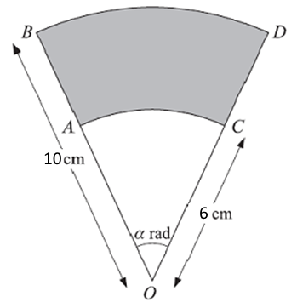
(a) Determine the value of $α$ for which the area of the shaded area
equals 36,8 cm². (4)
(b) Determine the circumference of the shaded area. (3)

Question 5 [15 marks]
5.1
(a) Write the following matrix equation as a set of equations:
$\left(\begin{matrix}4 & -3 \\ 2 & 6\end{matrix}\right)\left(\begin{matrix}x \\ y\end{matrix}\right)=\left(\begin{matrix}5 \\ -1\end{matrix}\right)$ (2)

(b) Use Cramer’s rule and solve for $x$.
Clearly show the determinants that you use and how you use Cramer’s rule. (6)

5.2 Determine the following:
(a) $\left(\begin{matrix}-60 & 25 & 35 \\ 55 & -18 & 40\end{matrix}\right)-\left(\begin{matrix}50 & 30 & -50 \\ 60 & -20 & 40\end{matrix}\right)$ (3)

(b) $\left(\begin{matrix}4 & 2 \\ 5 & -1\end{matrix}\right)×\left(\begin{matrix}2 & -3 \\ 4 & 0\end{matrix}\right)$ (4)

Question 6 [12 marks]
6.1 Determine the unit vector of vector $u=\left(2;-6\right)$. (4)
6.2 Given $a and b$with angle $θ$ that that is formed between the vectors.
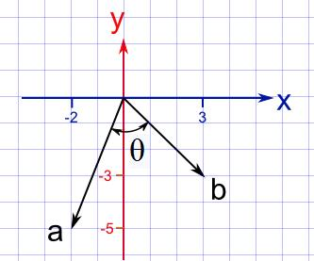
(a) Determine the dot product of vectors $a$and$b$. (3)
(b) Calculate the size of $θ$ in radians. (5)

Question 7 [15 marks]
Differentiate the following functions. It is not necessary to simplify the answers.
7.1 $f\left(x\right)=\frac{4}{x}+$ $2x^{5}$ $-7$ (3)
7.2 $g(x)=x^{4}\left(x^{2}-π\right)$ (3)
7.3 $y=$ $\frac{1}{\sqrt[6]{2x^{2}+7x-4}}$ (5)
7.4 $h\left(x\right)={\left(1-\frac{1}{\sqrt{x}}\right)}^{2}$ (4)

Question 8 [24 marks]
8.1 Determine the following integral $\int{(\sqrt{2x}+\frac{1}{x^{2}}+x^{5}+1)} dx$
It is not necessary to simplify the answer. (6)
8.2 The graph of $f(x)$ goes through the point (1;3) and the derivative of $f(x)$ is
$$f^{'}\left(x\right)=6x^{2}-10x.$$
Determine the equation of $f$. (6)
8.3 Show all the steps of integration that you use for this question.
The functions $f\left(x\right)=\sqrt{9-x}$ is sketched.
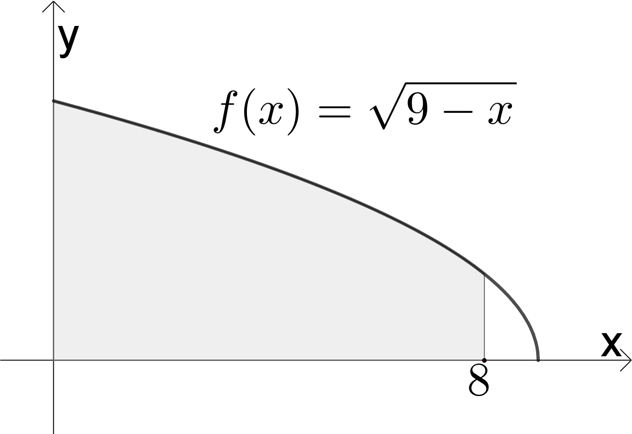
(a) Calculate the area of the shaded part, between $x=0$ and the $x=8$.
Clearly show all necessary steps. (8)

(b) Determine the volume of the body of rotation that is formed when
$f\left(x\right)$ rotates around the $x$-axis, between $x=0$and$x=8$.
Give the answer in terms of $π$. (4)
- END of the PAPER -

ALPHA MATHEMATICS FORMULA SHEET

MATRICES AND VECTORS:
$$\text{Cramer}\text{'s rule}\text{:} x_{i}=\frac{\left|A_{i}\right|}{\left|A\right|}$$
$$a∙b=\left|a\right|\left|b\right|\cos{θ}$$
$$a∙b=a_{x}b_{x}+a_{y}b_{y}$$

CALCULUS:
$$V=π\int_{a}^{b}{{\left[f\left(x\right)\right]}^{2} dx}$$ | $$\int_{a}^{b}{x^{n} dx={\left[\frac{x^{n+1}}{n+1}\right]}_{a}^{b}}$$

TRIGONOMETRY:
In a sector: $s=rθ$ and $A=\frac{1}{2}r^{2}θ$

TABLES WITH DERIVATIVES:
$$F(x)$$ | $$F^{'}\left(x\right)$$
$$ax^{n}$$ | $$nax^{n-1}$$
$$f\left[g\left(x\right)\right]$$ | $$f^{'}\left[g\left(x\right)\right].g^{'}\left(x\right)$$

Alpha Mathematics Grade 10 - Final examination 2019

ANSWER SHEET

Name and Surname: ______________________________________________________

Question  Total | 1  [20] | 2  [16] | 3  [11] | 4  [17] | 5  [15] | 6  [12] | 7  [15] | 8  [24] |  | TOTAL  130
Learner
mark

Question 1

1.1 | A | B | C | D
1.2 | A | B | C | D
1.3 | A | B | C | D
1.4 | A | B | C | D
1.5 | A | B | C | D
1.6 | A | B | C | D
1.7 | A | B | C | D
1.8 | A | B | C | D
1.9 | A | B | C | D
1.10 | A | B | C | D

DIAGRAM SHEET 1 [Question 2.3]
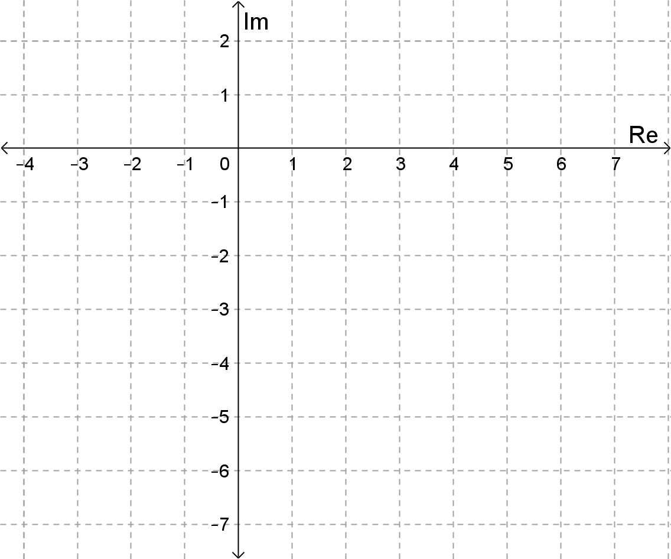

DIAGRAM SHEET 2 [Question 4.2]


