α-MATHEMATICS

Alpha Mathematics

Final examination 2018

Grade 11 Time: 2 ½ hours
Examiner: H. Botha Total: 165 marks
Moderator: R. Grobler

INSTRUCTIONS AND INFORMATION
Carefully read through the following instructions before answering the question paper:
- This question paper consists of 8 pages, a formula sheet of 1 page and a diagram sheet of 2 pages.
- Answer ALL 9 questions.
- Number the answers exactly the way the questions are numbered.
- Non-programmable calculators may be used, unless otherwise indicated in the question.
- Unless indicated otherwise, all answers, where necessary, must be given correct to two decimal places
- Cleary show all calculations, diagrams, graphs et cetera that you have used in determining the answers.
- Answers only will not necessarily be awarded full marks.
- The diagrams in the question paper are not necessarily drawn to scale.
- All angles are given in radians. Answers must also be given in radians if necessary.
- Write neat and legible.

Question 1 [20 marks]
This question must be answered on the answer sheet.
Each question has ONLY one correct answer and is worth two (2) marks. Mark the correct answer with an X on the answer sheet.

1.1 Solve for $x$ in $-\left|x-2\right|-4=0$.
(A) $x∈\{-2 ;6\}$
(B) $x∈\{-2 ;2\}$
(C) $x∈R$
(D) No solution for $x$

1.2 The following transformations are applied to the graph of $y=\arccos{x}$:
- horisontal shift of 2 units to the right,
- vertical shift of $\frac{π}{6}$ units upwards, and
- scale with a factor of 3.
The new graph’s equation is:
(A) $y=3\arccos\left(x-\frac{π}{6}\right)+2$
(B) $y=3\arccos{(x-2)}+\frac{π}{6}$
(C) $y=3\arccos{(x+2)}+\frac{π}{6}$
(D) $y=3\arccos\left(x+\frac{π}{6}\right)++2$

1.3 The invers function of $y=\sin\left(x-\frac{π}{2}\right)+1$ will be defined if the domain of $f$ is restricted to...
(A) $x∈\left[0;π\right]$
(B) $x∈\left[-\frac{π}{2} ;\frac{π}{2}\right]$
(C) $x∈\left[\frac{π}{2} ;\frac{3π}{2}\right]$
(D) $x∈\left[-1+\frac{π}{2} ;1+\frac{π}{2}\right]$

Use the following sketch of $f\left(x\right)$ for QUESTION 1.4 and QUESTION 1.5.
$$f\left(x\right)=\left\{\begin{matrix}-\left|x+2\right|+π & \text{if} & x≤-2 \\ \arccos\left(x+1\right) & \text{if} & -2<x<-1 \\ -\sqrt[3]{x} & \text{if} & x≥-1 ;x≠2\end{matrix}\right.$$
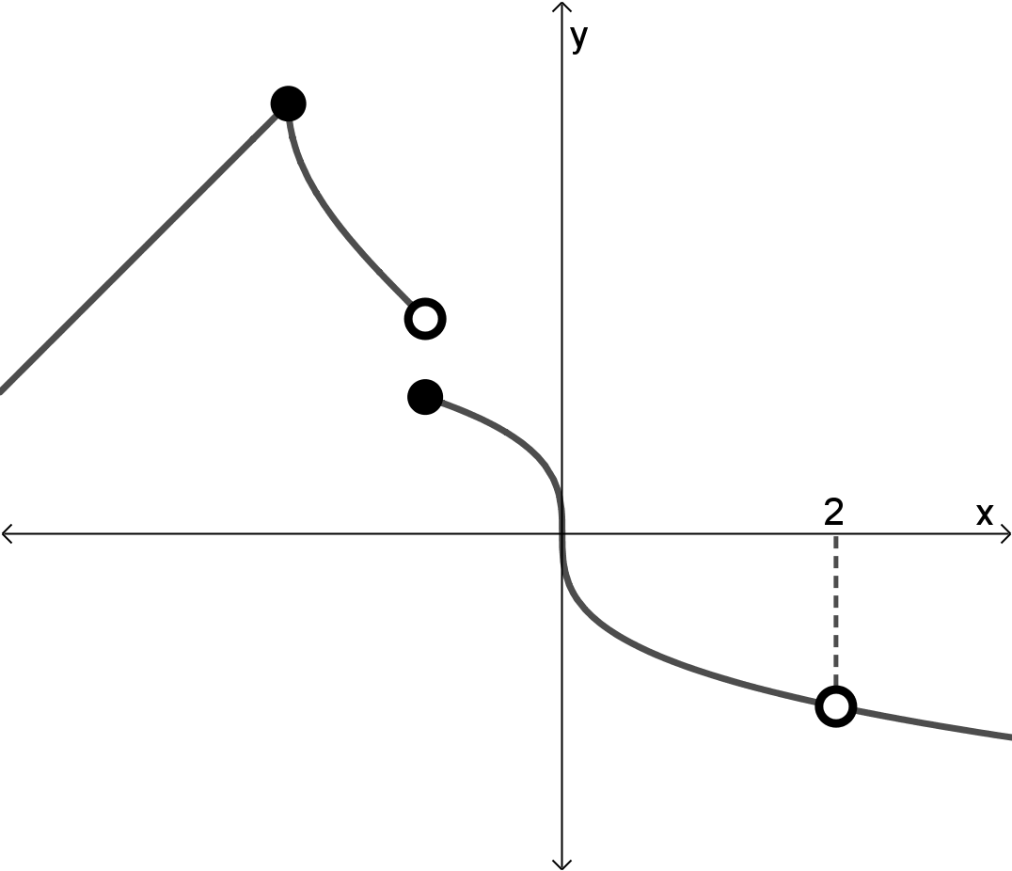
1.4 For which value(s) of $x$ has $f\left(x\right)$ a removeable discontinuity?
(A) $x=-1$
(B) $x=2$
(C) $x∈\left\{-2 ;0\right\}$
(D) $x∈\left\{-1 ;2\right\}$

1.5 For which values of $x$ will $f\left(x\right)$ not be differentiable?
(A) $x∈\left\{-1 ; 0 ; 2\right\}$
(B) $x∈\left\{0 ; 2\right\}$
(C) $x∈\left\{-2 ; -1 ;0 ; 2\right\}$
(D) $x∈\left\{-2 ; -1 ;2\right\}$

1.6 For which values of $x$ will the expansion of $\frac{1}{4+x}$ converge?
(A) $\left|x\right|<1$
(B) $\left|x\right|>\frac{1}{4}$
(C) $\left|x\right|<4$
(D) $\left|x\right|<\frac{1}{4}$

1.7 If $y=\cos{2x}$, then $\int{\frac{dy}{dx}}$ $dx=$
(A) $\cos{2x}+k$
(B) $\sin{2x}+k$
(C) $\frac{1}{2}\cos{2x}+k$
(D) $\frac{1}{2}\sin{2x}+k$

1.8 If $f\left(x\right)=\left|2x-4\right|-1$, then $f^{'}\left(2\right)=$
(A) $-2$
(B) $2$
(C) $0$
(D) Does not exist.

1.9 Given: $v=-2i+xj-3k$ and $u=-3j-2k$. The dot product between $u$ and $v$ is 10. Determine the value of $x$.
(A) $x=1$
(B) $x=-\frac{4}{3}$
(C) $x=4$
(D) $x=-2$

1.10 Which one of the following statements are true?
(A) The cross product of two vectors gives a scalar as answer.
(B) If $a×b=0$ then $a$ is perpendicular on $b$.
(C) The area of a parallelogram formed by $a$ and $b$ is $\left|a×b\right|$.
(D) If $a b=0$ then $a$ is parallel to $b$.

Question 2 [15 marks]
2.1 Solve for $x$ in:
(a) $\left|2-x\right|>3$ (4)
(b) $\left|x-2\right|=-x^{2}+4$, where $x<2$. (6)

2.2 Sketch the graph of $y=\frac{1}{2}\left|x-3\right|-1$. Show clearly all intercepts with the axis and the salient point on the sketch. Use DIAGRAM SHEET 1 for the sketch. (5)

Question 3 [21 marks]
3.1 $\sqrt{3}+5$ is a zero of $P\left(x\right)=x^{4}-8x^{3}+7x^{2}-6x+110$. Decompose $P\left(x\right)$
completely over $Z\left[x\right]$ and $C\left[x\right]$. (10)
3.2 Determine the coefficients of $x^{-1}$ in the expansion of ${\left(\sqrt{x}-\frac{1}{x^{2}}\right)}^{8}$. (6)
3.3 Determine and simplify the first 4 terms in ${\left(1+\frac{x}{4}\right)}^{-1}$. (5)

Question 4 [20 marks]
4.1 Decompose $\frac{x^{2}-4x+8}{\left(x-1\right)\left(x^{2}+4\right)}$ into partial fractions. (8)

4.2 Use Mathematical Induction and proof that the following statement is true for
all $n∈N$.
$$\sum_{p=1}^{n}{{\left(2p\right)}^{3}}=2n^{2}{\left(n+1\right)}^{2}$$ | (12)

Question 5 [15 marks]
Given: $u=i+2j-k$, $v=3j+5k$ and $w=5i-j+3k$
5.1 Determine the unit vector of vector $w$. (3)
5.2 Determine the size of the angle between vectors $u$ and $v$. (5)
5.3 Determine the area of the parallelogram that is formed by the vectors $u$ and $w$. (7)

Question 6 [24 marks]
6.1 Determine the invers function of $y=\sin{\frac{x}{2}}+1$. Write it in the form $y=…$ (4)

6.2 Given: $h\left(x\right)=\arccos\left(x-\frac{1}{2}\right)-\frac{π}{6}$
(a) Sketch the graph of $h.$ Cleary show all intercepts with the axis and coordinates of the endpoints of the function. Use DIAGRAM SHEET 2 for the sketch. (7)
(b) Describe the transformation, in words, that took place from $h$ to obtain the function $y=\arccos{x}+\frac{π}{6}$. (3)

6.3 In the diagram OAXB is a sector of a circle with midpoint O and radius 6 cm.
CAYB is a sector of another circle with midpoint C and radius 10 cm.
$Δ$ABC is equilateral with $\text{A}\hat{\text{C}}\text{B}=\frac{π}{3}$ radians and $\text{A}\hat{\text{O}}\text{B}=1,97$ radians.
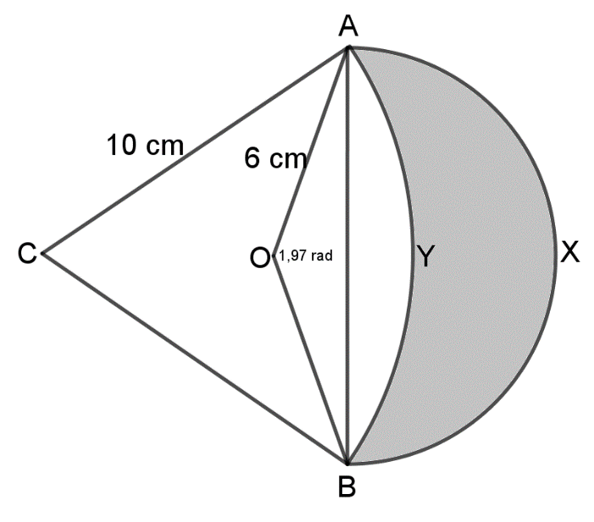
(a) Show that the area of OAYB is 25,64 cm². (7)
(b) Hence, determine the area of AXBY, the shaded region. (3)

Question 7 [20 marks]
7.1 Given $f\left(x\right)=\left\{\begin{matrix}2x+2 & \text{if} & x<3 \\ 3x^{2}-3x-m & \text{if} & x≥3\end{matrix}\right.$
(a) Determine the value of $m$ for which $f$ is continuous at $x=3$. (4)
(b) Determine if $f$ is differentiable at $x=3$. Motivate your answer
algebraically. (4)

7.2 Differentiate the following. It is not necessary to simply the answers.
(a) $D_{x}\left[\arctan{\sqrt{x}} \right]$ (3)
(b) $\frac{d}{dx}\left[\frac{x}{2}×\cot\left(\frac{2}{x}\right)\right]$ (4)
(c) $f^{'}\left(x\right)$ if $f\left(x\right)=$ ${\left(\frac{x^{3}}{x^{2}-1}\right)}^{4}$ (5)

Question 8 [10 marks]
8.1 Determine the following integral $\int{\frac{2}{\sqrt{x}}}$ $-\sec^{2}{5x}+π dx$. (4)
8.2 If $\int_{1}^{k}{\frac{1}{\sqrt{-x^{2}+2x}}}$ $dx=$ $\frac{π}{6}$, determine the value of $k$. (6)

Question 9 [20 marks]
9.1 The function $f\left(x\right)=\sqrt{16-2x}$ and $g\left(x\right)=m$ (horisontal line) are sketched below.
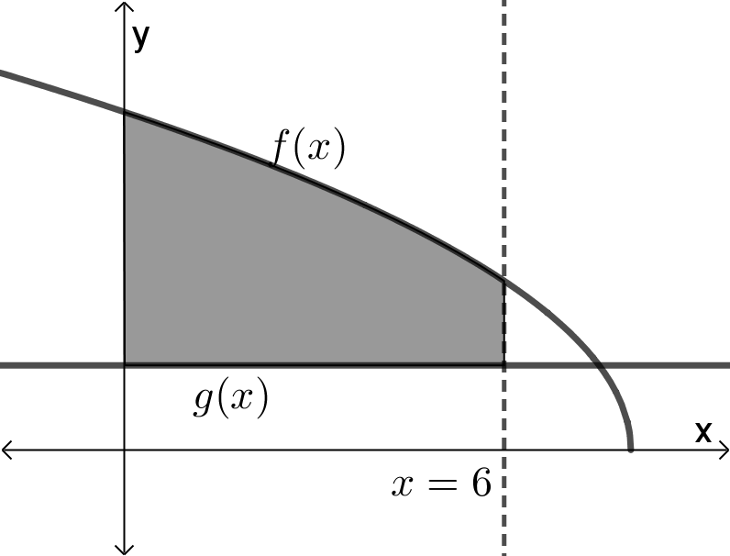
$$m$$
The area of the shaded region, between $x=0$ and $x=6$, is $12\frac{2}{3}$.
Determine the value of $m$. (11)

9.2 The sketch below is defined by $f\left(x\right)=\left\{\begin{matrix}x & \text{if} & 0≤x≤6 \\ \sqrt{12x-x^{2}} & \text{if} & 6<x≤12\end{matrix}\right.$
and the horisontal line $y=3$.
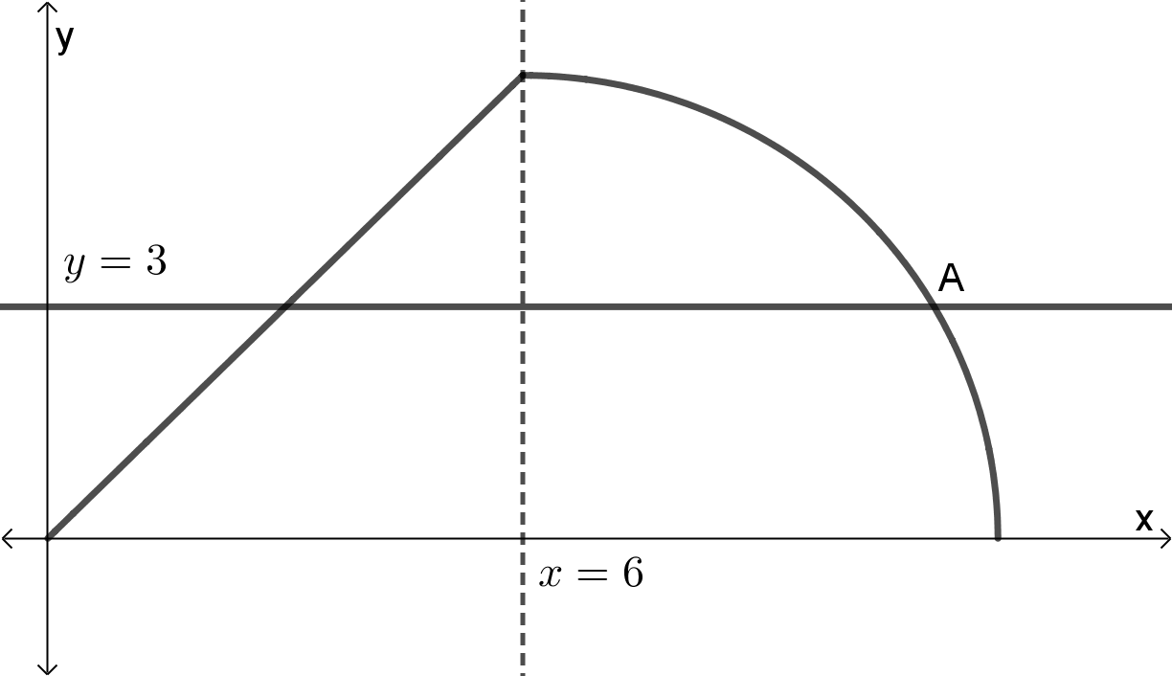
(a) Write down an expression for which the volume of the solid can be obtained if $f\left(x\right)$ rotates about the $x$-axis, between $x=0$ and $x=12$. Do not integrate the expression. (3)
(b) Use Newton’s method do determine the $x$-coordinate of A, the intersect of $y=f\left(x\right)$ and $y=3$, correct to five decimal places.
Use $x_{1}=11$ as first approximation. (6)

- END OF THE QUESTION PAPER -

ALPHA MATHEMATICS FORMULA SHEET
ALGEBRA:
$$x=\frac{-b±\sqrt{b^{2}-4ac}}{2a}$$ | $$\left|x\right|=\left\{\begin{matrix}x & \text{if} & x≥0 \\ -x & \text{if} & x<0\end{matrix}\right.$$
$${\left(a+b\right)}^{n}=\sum_{r=0}^{n}{\left(\begin{matrix}n \\ r\end{matrix}\right) a^{n-r}b^{r}}$$ | $${\left(1+x\right)}^{n}=1+\frac{nx}{1!}+\frac{n(n-1)x^{2}}{2!}+… ;\text{if} \left|x\right|<1$$
VECTORS:
$a b=\left|a\right|\left|b\right|\cos{θ}$ $a b=a_{x}b_{x}+a_{y}b_{y}+a_{z}b_{z}$
CALCULUS:
$$\int_{a}^{b}{x^{n} dx={\left[\frac{x^{n+1}}{n+1}\right]}_{a}^{b}}$$ | $$V=π\int_{a}^{b}{{\left[f\left(x\right)\right]}^{2} dx}$$ | $$a_{n+1}=a_{n}-\frac{f\left(a_{n}\right)}{f^{'}\left(a_{n}\right)}$$
TRIGONOMETRY:
In a sector: $s=rθ$ and $A=\frac{1}{2}r^{2}θ$
Identities: $\sin^{2}{x}+\cos^{2}{x=1}$ $\tan^{2}{x}+1=\sec^{2}{x}$ $\cot^{2}{x}+1=cosec^{2}x$
 |  | $$\operatorname{cosec}{x}=\frac{1}{\sin{x}}$$ | $$\sec{x}=\frac{1}{\cos{x}}$$ | $$\cot{x}=\frac{1}{\tan{x}}$$
 |  | $$y-y_{1}=m\left(x-x_{1}\right)$$ | $$m=\frac{y_{2}-y_{1}}{x_{2}-x_{1}}$$ | $$m=\tan{θ}$$
$$\text{In} Δ\text{ABC}:$$ | $$\frac{a}{\sin{A}}=\frac{b}{\sin{B}}=\frac{c}{\sin{C}}$$ |  | $$a^{2}=b^{2}+c^{2}-2bc.\cos{A}$$
$$\text{area} ∆\text{ABC}=\frac{1}{2}ab.\sin{C}$$
TABLE WITH DERIVATIVES:
  $$F(x)$$ | $$F^{'}\left(x\right)$$
  $$ax^{n}$$ | $$nax^{n-1}$$
  $$\sin{x}$$ | $$\cos{x}$$
  $$\cos{x}$$ | $$-\sin{x}$$
  $$\tan{x}$$ | $$\sec^{2}{x}$$
  $$\cot{x}$$ | $$-{cosec}^{2}{x}$$
  $$\sec{x}$$ | $$\sec{x}.\tan{x}$$
  $$\operatorname{cosec}{x}$$ | $$-\operatorname{cosec}{x}.\cot{x}$$
  $$F(x)$$ | $$F^{'}\left(x\right)$$
  $$\operatorname{bgsin}{x}$$  $$\arcsin{x}$$ | $$\frac{1}{\sqrt{1-x^{2}}}$$
  $$\operatorname{bgcos}{x}$$  $$\arccos{x}$$ | $$\frac{-1}{\sqrt{1-x^{2}}}$$
  $$\operatorname{bgtan}{x}$$  $$\arctan{x}$$ | $$\frac{1}{x^{2}+1}$$
  $$f\left(x\right).g\left(x\right)$$ | $$f^{'}\left(x\right).g\left(x\right)+f\left(x\right).g'(x)$$
  $$\frac{f\left(x\right)}{g\left(x\right)}$$ | $$\frac{f^{'}\left(x\right).g\left(x\right)-f\left(x\right).g'(x)}{{\left[g\left(x\right)\right]}^{2}}$$
  $$f[g\left(x\right)]$$ | $$f^{'}\left[g\left(x\right)\right].g'(x)$$

Alpha Mathematics Grade 11 - Final examination 2018

ANSWER SHEET

Name and Surname: ______________________________________________________

Question  Total | 1  [20] | 2  [15] | 3  [21] | 4  [20] | 5  [15] | 6  [24] | 7  [20] | 8  [10] | 9  [20] |  | TOTAL  165
Student mark

Question 1

1.1 | A | B | C | D
1.2 | A | B | C | D
1.3 | A | B | C | D
1.4 | A | B | C | D
1.5 | A | B | C | D
1.6 | A | B | C | D
1.7 | A | B | C | D
1.8 | A | B | C | D
1.9 | A | B | C | D
1.10 | A | B | C | D

DIAGRAM SHEET 1 [Question 2.2]
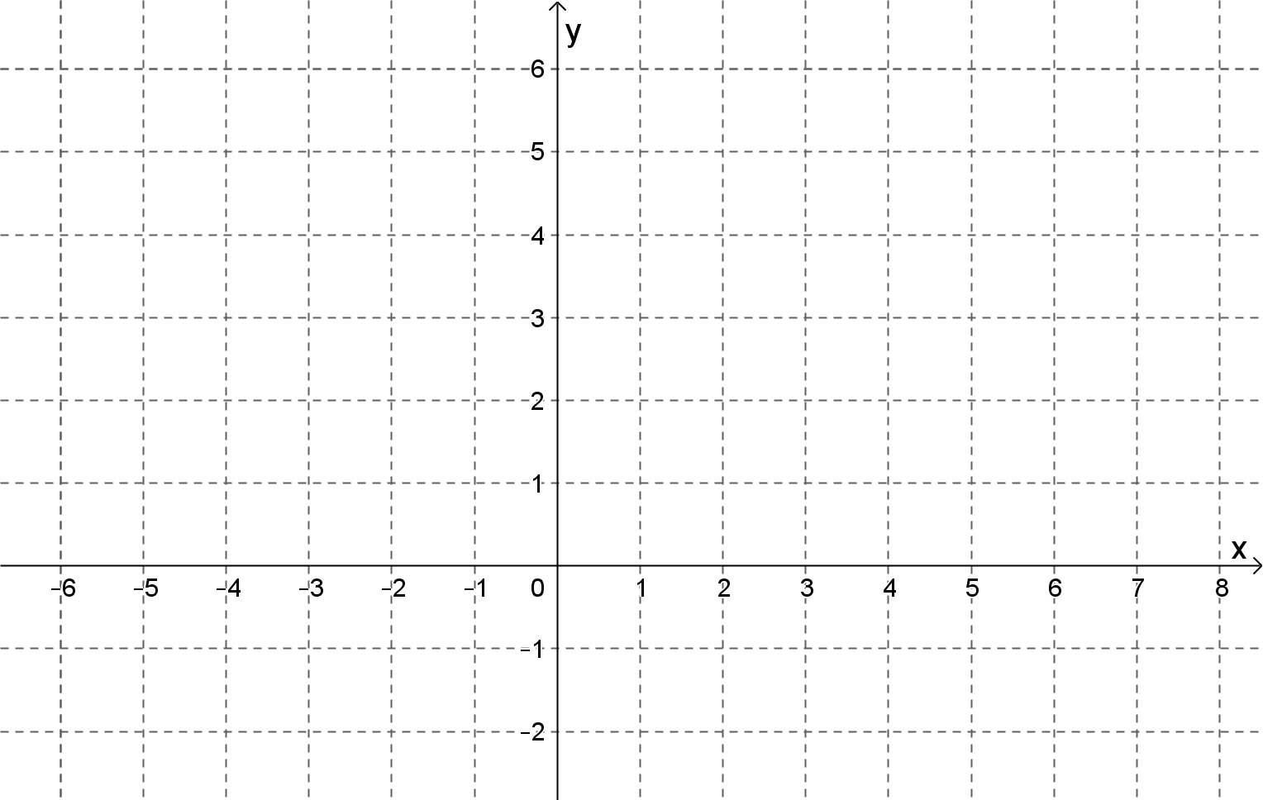

DIAGRAM SHEET 2 [Question 6.2(a)]


