α-WISKUNDE

Alpha Wiskunde Graad 11 / Alpha Mathematics Grade 11
Finale eksamen 2018 / Final examination 2018

MEMORANDUM

Totaal / Total: 165 punte / marks

Eksaminator / Examiner: Hennie Botha
Moderator: Rika Grobler

Hierdie memorandum bestaan uit 14 bladsye. /
This memorandum consists of 14 pages.

Vraag / Question 1 [20 punte / marks]

1.1 | A | B | C | D
1.2 | A | B | C | D
1.3 | A | B | C | D
1.4 | A | B | C | D
1.5 | A | B | C | D
1.6 | A | B | C | D
1.7 | A | B | C | D
1.8 | A | B | C | D
1.9 | A | B | C | D
1.10 | A | B | C | D

NR.  NO | ANTWOORD ANSWER | BEREKENINGE (nie vir nasien doeleindes nie)  CALCULATIONS (not for marking purpose) | PUNTE MARKS
1.1 | D | $$-\left|x-2\right|-4=0 \\ \left|x-2\right|=-4$$  $∴$ Geen oplossing (Absolute waarde kan nie negatief wees nie) | 2
1.2 | B | $$y=3\operatorname{bgcos}{(x-2)}+\frac{π}{6}$$ | 2
1.3 | A | $$-\frac{π}{2}≤x-\frac{π}{2}≤\frac{π}{2} \\ 0≤x≤π$$ | 2
1.4 | B | Verwyderbare diskontinuïteit by $x=2$. | 2
1.5 | D | $$x∈\left\{-2 ; -1 ;2\right\}$$ | 2
1.6 | C | $${\left(4+x\right)}^{-1}=4^{-1}{\left(1+\frac{x}{4}\right)}^{-1}$$  $$\left|\frac{x}{4}\right|<1$$  $$\left|x\right|<4$$ | 2
1.7 | A | $$y=\cos{2x}$$  $$\int{\frac{dy}{dx}} dx=\cos{2x}+k$$ | 2
1.8 | D | $f^{'}\left(2\right)$ is die gradiënt in die knakpunt, wat nie bestaan nie. | 2
1.9 | B | $$u v=\left(-2\right)\left(0\right)+x\left(-3\right)+\left(-3\right)\left(-2\right)=10 \\ -3x+6=10 \\ x=-\frac{4}{3}$$ | 2
1.10 | C | Die oppervlakte van ‘n parallelogram wat gevorm word deur $a$ en $b$ is $\left|a×b\right|$. $-$ is waar! | 2

Vraag / Question 2 [15 punte / marks]
NR.  NO | ANTWOORD / ANSWER | PUNTE / MARKS
2.1 (a) | $$\left|2-x\right|>3$$  $2-x>3$ of / or $2-x<-3$  $x<-1$ $x>5$ | - $2-x>3$  - $2-x<-3$  - Antwoord $x<-1$  - Antwoord $x>5$  [4 punte / marks]
2.1 (b) | $$\left|x-2\right|=-x^{2}+4$$  As $x-2<0 ⟹x<2$, dan:  $$x-2=-(-x^{2}+4) \\ -x^{2}+x+2=0 \\ x^{2}-x-2=0 \\ \left(x-2\right)\left(x+1\right)=0$$  $∴x=2$ (N.V.T) of / or $x=-1$ | - Voorwaarde  - Vergelyking  - Vereenvoudig  - Faktoriseer  - Antwoord $x=2$ (N.V.T.)  - Antwoord $x=-1$  [6 punte / marks]
2.2 | 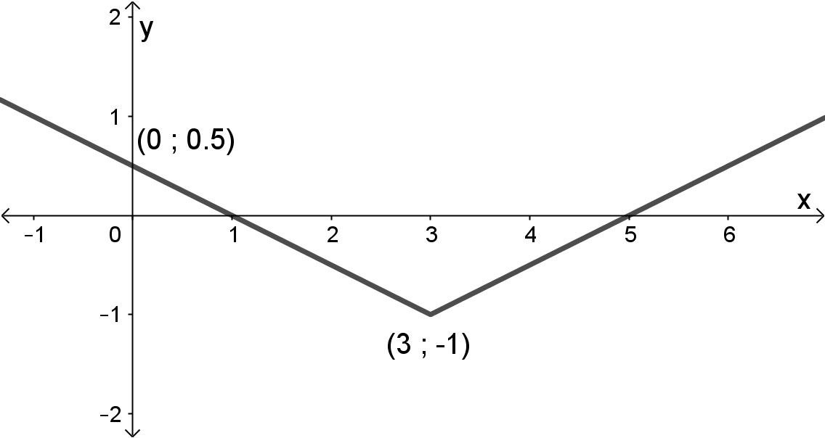 | - Knakpunt $\left(3;-1\right)$  - ✔$x$-afsnitte by $1$ en $5$  - $y$-afsnit by $\frac{1}{2}$  - Vorm  [5 punte / marks]

Vraag / Question 3 [21 punte / marks]
NR.  NO | ANTWOORD / ANSWER | PUNTE / MARKS
3.1 | As $x=\sqrt{3}+5$ ‘n nulpunt is dan is $x=-\sqrt{3}+5$ ook ‘n nulpunt.  $\left(x-5-\sqrt{3}\right)\left(x-5+\sqrt{3}\right)$  $={\left(x-5\right)}^{2}-3$  $=x^{2}-10x+22$ is ‘n faktor.  OF / OR  $$x=\sqrt{3}+5 \\ {\left(x-5\right)}^{2}={\left(\sqrt{3}\right)}^{2} \\ x^{2}-10x+22=0$$  Doen langdeling, dan is:  $$P\left(x\right)=x^{4}-8x^{3}+7x^{2}-6x+110 \\ = \left(x^{2}-10x+22\right)\left(x^{2}+2x+5\right)∈Z\left[x\right] \\ =\left(x-5-\sqrt{3}\right)\left(x-5+\sqrt{3}\right)\left(x+1+2i\right)\left(x+1-2i\right)∈C\left[x\right]$$  Bepaal faktore van $x^{2}+2x+5$:  $$x=\frac{-2±\sqrt{2^{2}-4(5)}}{2} \\ =\frac{-2±\sqrt{-16}}{2} \\ =-1±2i$$ | - Twee hakies  - Vereenvoudig  - Faktor  OF / OR  - Vergelyking  - Kwadreer beide kante  - Faktor  - ✔✔ $x^{2}+2x+5$  - $∈Z\left[x\right]$  - $\left(x+1+2i\right)$  - $\left(x+1-2i\right)$  - Vervang in formule (of enige ander metode)  [10 punte / marks]
3.2 | $${\left(\sqrt{x}-\frac{1}{x^{2}}\right)}^{8}$$  $$\left(\begin{matrix}8 \\ r\end{matrix}\right){\left(x^{\frac{1}{2}}\right)}^{8-r}{\left(-x^{-2}\right)}^{r}$$  $$=\left(\begin{matrix}8 \\ r\end{matrix}\right)x^{4-\frac{1}{2}r}{\left(-1\right)}^{r}\left(x^{-2r}\right)$$  $$∴4-\frac{1}{2}r-2r=-1⟹r=2$$  $$=\left(\begin{matrix}8 \\ 2\end{matrix}\right){\left(-1\right)}^{2}x^{-1}$$  $$=28x^{-1}$$  Koëffisiënt van $x^{-1}$ is 28. | - ✔ Vervang in formule  - Vereenvoudig  - ✔ $r=2$  (indien $r$ verkeerd, maks 3/5)  - Antwoord $28$  [6 punte / marks]
3.3 | $${\left(1+\frac{x}{4}\right)}^{-1}$$  $$=1+\left(-1\right)\left(\frac{x}{4}\right)+\frac{\left(-1\right)\left(-2\right)}{2!}{\left(\frac{x}{4}\right)}^{2}+\frac{\left(-1\right)\left(-2\right)\left(-3\right)}{3!}{\left(\frac{x}{4}\right)}^{3}$$  $$=1-\frac{x}{4}+\frac{x^{2}}{16}-\frac{x^{3}}{64}$$ | - ✔✔ Vervang in formule  (elke term, behalwe die eerste term)  - ✔ Vereenvoudig  [5 punte / marks]

Vraag / Question 4 [20 punte / marks]
NR.  NO | ANTWOORD / ANSWER | PUNTE / MARKS
4.1 | $$\frac{x^{2}-4x+8}{\left(x-1\right)\left(x^{2}+4\right)}≡\frac{A}{x-1}+\frac{Bx+C}{x^{2}+4} \\ x^{2}-4x+8≡A\left(x^{2}+4\right)+\left(Bx+C\right)\left(x-1\right)$$  Stel $x=1$: $5=5A ⟹A=1$  Stel $x=0:$ $8=4A-C$  $8=4\left(1\right)-C$  $C=-4$  Stel $x=-1$ (enige waarde):  $13=5A+2B-2C$  $13=5\left(1\right)+2B-2(-4)$  $B=0$  $$∴\frac{x^{2}-4x+8}{\left(x-1\right)\left(x^{2}+4\right)}≡\frac{1}{x-1}-\frac{4}{x^{2}+4}$$ | - ✔ Ontbind  - Vermenigvuldig met KGV  - $A=1$  - $C=-4$  - Vergelyking  - $B=0$  - Antwoord
4.1 | OF / OR | OF / OR
4.1 | $$\frac{x^{2}-4x+8}{\left(x-1\right)\left(x^{2}+4\right)}≡\frac{A}{x-1}+\frac{Bx+C}{x^{2}+4} \\ x^{2}-4x+8≡A\left(x^{2}+4\right)+\left(Bx+C\right)\left(x-1\right) \\ ≡Ax^{2}+4A+Bx^{2}-Bx+Cx-C \\ ≡x^{2}\left(A+B\right)+x\left(C-B\right)+\left(4A-C\right)$$  Stel $x=1$: $5=5A ⟹A=1$  $A+B=1$ $C-B=-4$ $4A-C=8$  $B=0$ $C=-4$ $C=-4$  $$∴\frac{x^{2}-4x+8}{\left(x-1\right)\left(x^{2}+4\right)}≡\frac{1}{x-1}-\frac{4}{x^{2}+4}$$ | - ✔ Ontbind  - Vermenigvuldig met KGV  - Groepeer  - $A=1$  - $B=0$  - $C=-4$  - Antwoord  [8 punte / marks]
NR.  NO | ANTWOORD / ANSWER | PUNTE / MARKS
4.2 | $$\sum_{p=1}^{n}{{\left(2p\right)}^{3}}=2n^{2}{\left(n+1\right)}^{2}$$  $$2^{3}+4^{3}+6^{3}+…+{\left(2n\right)}^{3}=2n^{2}{\left(n+1\right)}^{2}$$  Stel / Let $n=1$: LK $=8$ RK $=2{\left(1+1\right)}^{2}=8$  $∴$ LK $=$ RK  $∴$ bewering is waar vir / statement is true for $n=1$.  Aanvaar die bewering is waar as / Accept the statement is true for $n=k$:  $$2^{3}+4^{3}+6^{3}+…+{\left(2k\right)}^{3}=2k^{2}{\left(k+1\right)}^{2}$$  Beskou / Consider $n=k+1:$  $$\text{LK} =2^{3}+4^{3}+6^{3}+…+{\left(2k\right)}^{3}+{\left(2\left(k+1\right)\right)}^{3} \\ =2k^{2}{\left(k+1\right)}^{2}+8{\left(k+1\right)}^{3} \\ =2{\left(k+1\right)}^{2}\left(k^{2}+4\left(k+1\right)\right) \\ =2{\left(k+1\right)}^{2}\left(k^{2}+4k+4\right) \\ =2{\left(k+1\right)}^{2}{\left(k+2\right)}^{2}$$ | - Uitbrei van terme  - LK $=$ RK $=8$  - Rede  - Aanvaar...  - Stelling met $n=k$  - Eerste $k$ terme  - $(k+1)$’de term  - Vervang eerste $k$ terme met $2k^{2}{\left(k+1\right)}^{2}$  - Faktoriseer  - Antwoord van LK
4.2 | OF / OR | OF / OR
4.2 | $$\text{LK} =2^{3}+4^{3}+6^{3}+…+{\left(2k\right)}^{3}+{\left(2\left(k+1\right)\right)}^{3} \\ =2k^{2}{\left(k+1\right)}^{2}+8{\left(k+1\right)}^{3} \\ =2k^{2}\left(k^{2}+2k+1\right)+8\left(k^{3}+3k^{2}+3k+1\right) \\ =2k^{4}+4k^{3}+2k^{2}+8k^{3}+24k^{2}+24k+8 \\ =2k^{4}+12k^{3}+26k^{2}+24k+8$$ | - Eerste $k$ terme  - $(k+1)$’de term  - Vervang eerste $k$ terme met $2k^{2}{\left(k+1\right)}^{2}$  - Vermenigvuldig hakies uit  - Antwoord van LK
4.2 | $$\text{RK}=2{\left(k+1\right)}^{2}{\left(k+2\right)}^{2} \\ =2\left(k^{2}+2k+1\right)\left(k^{2}+4k+4\right) \\ =2k^{4}+12k^{3}+26k^{2}+24k+8$$  $∴$ LK $=$ RK  Die bewering is waar as $n=1$. As die bewering waar is vir $n=k$, is dit ook waar vir $n=k+1$. Dus is die bewering waar vir alle $n∈N$. /  The statement is true for $n=1$. If the statement is true for $n=k$, it is also true for $n=k+1$. Thus, the statement is true for all $n∈N$. | - Antwoord van RK (enige een, hang af van die “OF” hierbo wat die leerder gedoen het)  - Storie  [12 punte / marks]

Vraag / Question 5 [15 punte / marks]
NR.  NO | ANTWOORD / ANSWER | PUNTE / MARKS
5.1 | $$\left|w\right|=\sqrt{5^{2}+1^{2}+3^{2}}=\sqrt{35}=5,92$$  Eenheidsvektor van $w$ is:  $$\frac{w}{\left|w\right|}=\left(\frac{5}{\sqrt{35}};-\frac{1}{\sqrt{35}};\frac{3}{\sqrt{35}}\right)=\frac{5}{\sqrt{35}}i-\frac{1}{\sqrt{35}}j+\frac{3}{\sqrt{35}}k$$ | - Grootte van $w$, $\left|w\right|$  - Metode, $\frac{w}{\left|w\right|}$  - Antwoord (enige vorm)  [3 punte / marks]
5.2 | $$\left|u\right|=\sqrt{1^{2}+2^{2}+1^{2}}=\sqrt{6}$$  $$\left|v\right|=\sqrt{0^{2}+3^{2}+5^{2}}=\sqrt{34}$$  $$u v=\left(1\right)\left(0\right)+\left(2\right)\left(3\right)+\left(-1\right)\left(5\right)=1$$  $$u v=\left|u\right|\left|v\right|\cos{θ} \\ 1=\sqrt{6}\sqrt{34}\cos{θ} \\ \cos{θ}=\frac{1}{\sqrt{6}\sqrt{34}} \\ θ=1.50 \text{rad}$$ | - Grootte van $u$, $\left|u\right|$  - Grootte van $v$, $\left|v\right|$  - Puntproduk, $u v$  - Vervang in formule  - Antwoord  [5 punte / marks]
5.3 | $$u×w=\left|\begin{matrix}i & j & k \\ 1 & 2 & -1 \\ 5 & -1 & 3\end{matrix}\right| \\ =i\left|\begin{matrix}2 & -1 \\ -1 & 3\end{matrix}\right|-j\left|\begin{matrix}1 & -1 \\ 5 & 3\end{matrix}\right|+k\left|\begin{matrix}1 & 2 \\ 5 & -1\end{matrix}\right| \\ =i\left(6-1\right)-j\left(3+5\right)+k(-1-10) \\ =5i-8j-11k$$  Oppervlakte van parallelogram:  $$\left|u×w\right|=\sqrt{5^{2}+8^{2}+{11}^{2}}=\sqrt{210}=14.49$$ | - Determinant van $u×w$  - ✔✔ Elke determinant  - Antwoord  - Metode, $\left|u×w\right|$  - Antwoord  [7 punte / marks]

Vraag / Question 6 [24 punte / marks]
NR.  NO | ANTWOORD / ANSWER | PUNTE / MARKS
6.1 | $$y=\sin{\frac{x}{2}}+1 \\ x=\sin{\frac{y}{2}}+1 \\ x-1=\sin{\frac{y}{2}} \\ \frac{y}{2}=\operatorname{bgsin}\left(x-1\right) \\ y=2\operatorname{bgsin}\left(x-1\right)$$ | - Ruil $x$ en $y$ om  - $-1$  - $\operatorname{bgsin}{}$  - Antwoord  [4 punte / marks]
6.2 (a) | 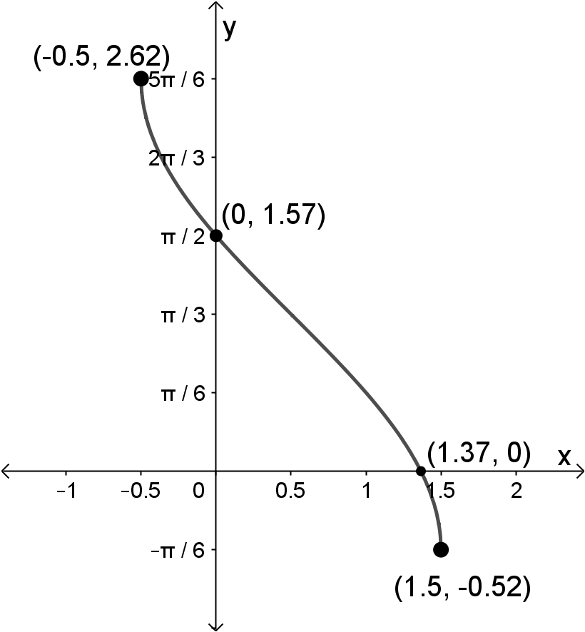 | - ✔ Eindpunt $\left(-\frac{1}{2};\frac{5π}{6}\right)$  - ✔ Eindpunt $\left(\frac{3}{2};-\frac{π}{6}\right)$  - $y$-afsnit $\frac{π}{2}$  - $x$-afsnit $1,37$  - Vorm  [7 punte / marks]
6.2 (b) | Translasie van $\frac{1}{2}$ eenhede horisontaal na links en $\frac{π}{3}$ eenhede vertikaal opwaarts. | - $\frac{1}{2}$ eenhede horisontaal links  - $\frac{π}{3}$ eenhede  - vertikaal opwaarts  [3 punte / marks]
6.3 (a) | Sektor ACB $=\frac{1}{2}\left({10}^{2}\right)\left(\frac{π}{3}\right)=\frac{50π}{3}=52,3598$  $∆$ACB $=\frac{1}{2}\left({10}^{2}\right)\sin{\frac{π}{3}}=25\sqrt{3}=43,3012$  $∆$OAB $=\frac{1}{2}\left(6^{2}\right)\sin\left(1,97\right)=16,5846$  $∴$ Area $=52,36-43,30+16,58=25,64$ | - ✔ Sektor ACB & Antwoord  - ✔ $∆$ACB & Antwoord  - ✔ $∆$OAB & Antwoord  - Antwoord  [7 punte / marks]
6.3 (b) | Sektor OAXB $=\frac{1}{2}\left(6^{2}\right)\left(1,97\right)=35,46$  Area van gearseerde deel $=35,46-25,64=9,82$ | - Sektor OAXB formule  - $35,46$  - Antwoord  [3 punte / marks]

Vraag / Question 7 [20 punte / marks]
NR.  NO | ANTWOORD / ANSWER | PUNTE / MARKS
7.1 (a) | $$\lim_{x→3^{-}}{f\left(x\right)}=\lim_{x→3}\left(2x+2\right)=2\left(3\right)+2=8$$  $$\lim_{x→3^{+}}{f\left(x\right)}=\lim_{x→3}\left(3x^{2}-3x-m\right)=3{\left(3\right)}^{2}-3\left(3\right)-m=18-m$$  Dus $f$ is kontinu by $x=3$ as:  $$\lim_{x→3^{-}}{f\left(x\right)}=\lim_{x→3^{+}}{f\left(x\right)} \\ 8=18-m \\ m=10$$ | - Stel gelyk  - $8$  - $18-m$  - Antwoord $m=10$  [4 punte / marks]
7.1 (b) | $$\lim_{x→3^{-}}{f'\left(x\right)}=\lim_{x→3}{2}=2$$  $$\lim_{x→3^{+}}{f'\left(x\right)}=\lim_{x→3}\left(6x-3\right)=6\left(3\right)-3=15$$  Dus $f$ is nie differensieerbaar by $x=3$ want  $$\lim_{x→3^{-}}{f'\left(x\right)}≠\lim_{x→3^{+}}{f'\left(x\right)}$$ | - $2$  - $6x-3$  - $15$  - Antwoord & Rede  [4 punte / marks]
7.2 (a) | $$\frac{1}{1+{\left(\sqrt{x}\right)}^{2}}×\frac{1}{2}x^{-\frac{1}{2}}$$ | - $\frac{1}{1+{\left(\sqrt{x}\right)}^{2}}$  - $\frac{1}{2}$  - $x^{-\frac{1}{2}}$  [3 punte / marks]
7.2 (b) | Produkreël:  $$\frac{1}{2}\cot\left(\frac{2}{x}\right)-\frac{x}{2}{cosec}^{2}\left(\frac{2}{x}\right)×\left(-2x^{-2}\right)$$ | - $\frac{1}{2}$  - Oorspronklike funksies  - ${cosec}^{2}\left(\frac{2}{x}\right)$  - $-2x^{-2}$  [4 punte / marks]

NR.  NO | ANTWOORD / ANSWER | PUNTE / MARKS
7.2 (c) | $$f\left(x\right)={\left(\frac{x^{3}}{x^{2}-1}\right)}^{4} \\ f^{'}\left(x\right)=4{\left(\frac{x^{3}}{x^{2}-1}\right)}^{3}\left(\frac{3x^{2}\left(x^{2}-1\right)-x^{3}\left(2x\right)}{{\left(x^{2}-1\right)}^{2}}\right)$$ | - $4$  - ${\left(\frac{x^{3}}{x^{2}-1}\right)}^{3}$  - $3x^{2}\left(x^{2}-1\right)$  - $x^{3}\left(2x\right)$  - ${\left(x^{2}-1\right)}^{2}$
7.2 (c) | OF / OR | OF / OR
7.2 (c) | $$f\left(x\right)=\frac{x^{12}}{{\left(x^{2}-1\right)}^{4}} \\ f^{'}\left(x\right)=\frac{12x^{11}×{\left(x^{2}-1\right)}^{4}-x^{12}×4{\left(x^{2}-1\right)}^{3}\left(2x\right)}{{\left(x^{2}-1\right)}^{8}}$$ | - $12x^{11}$  - Oorspronklike funksies  - $4$  - ${\left(x^{2}-1\right)}^{3}\left(2x\right)$  - ${\left(x^{2}-1\right)}^{8}$
7.2 (c) | OF / OR | OF / OR
7.2 (c) | $$f\left(x\right)={\left(x^{3}{\left(x^{2}-1\right)}^{-1}\right)}^{4} \\ f^{'}\left(x\right)=4{\left(x^{3}{\left(x^{2}-1\right)}^{-1}\right)}^{3}\left[3x^{2}{\left(x^{2}-1\right)}^{-1}-x^{3}{\left(x^{2}-1\right)}^{-2}\left(2x\right)\right]$$ | - $4$  - ${\left(x^{3}{\left(x^{2}-1\right)}^{-1}\right)}^{3}$  - $3x^{2}$  - Oorspronklike funksies  - $-{\left(x^{2}-1\right)}^{-2}\left(2x\right)$
7.2 (c) | OF / OR | OF / OR
7.2 (c) | $$f\left(x\right)=\frac{x^{12}}{{\left(x^{2}-1\right)}^{4}} \\ =x^{12}{\left(x^{2}-1\right)}^{-4} \\ f^{'}\left(x\right)=12x^{11}{\left(x^{2}-1\right)}^{-4}-4x^{12}{\left(x^{2}-1\right)}^{-5}\left(2x\right)$$ | - $12x^{11}$  - Oorspronklike funksies  - $-4$  - ${\left(x^{2}-1\right)}^{-5}$  - $2x$  [5 punte / marks]

Vraag / Question 8 [10 punte / marks]
NR.  NO | ANTWOORD / ANSWER | PUNTE / MARKS
8.1 | $$\int{2x^{-\frac{1}{2}}-\sec^{2}{5x}+π} dx$$  $$=2x^{\frac{1}{2}}×2-\tan{5x}×\frac{1}{5}+πx+k$$ | - $2x^{\frac{1}{2}}×2$  - $\tan{5x}$  - $\frac{1}{5}$  - $πx$  [4 punte / marks]
8.2 | $$\int_{1}^{k}{\frac{1}{\sqrt{-x^{2}+2x}}}dx=\frac{π}{6}$$  Voltooi die vierkant:  $$-x^{2}+2x=-\left[x^{2}-2x\right] \\ =-\left[x^{2}-2x+1^{2}-1^{2}\right] \\ =-\left[{\left(x-1\right)}^{2}-1\right] \\ =1-{\left(x-1\right)}^{2}$$  $$\int_{1}^{k}{\frac{1}{\sqrt{1-{\left(x-1\right)}^{2}}}}dx=\frac{π}{6} \\ {\left.\operatorname{bgsin}\left(x-1\right)\right|}_{1}^{k}=\frac{π}{6} \\ \operatorname{bgsin}{(k-1)}-\operatorname{bgsin}{0}=\frac{π}{6} \\ \operatorname{bgsin}\left(k-1\right)=\frac{π}{6} \\ k=\sin{\frac{π}{6}}+1 \\ k=\frac{3}{2}$$ | - ✔ Voltooi die vierkant  - $\operatorname{bgsin}\left(x-1\right)$  - Vervang grense in  - Vereenvoudig  - Antwoord $k=\frac{3}{2}$  [6 punte / marks]

Vraag / Question 9 [20 punte / marks]
NR.  NO | ANTWOORD / ANSWER | PUNTE / MARKS
9.1 | $$\text{Area}=\int_{0}^{6}{f\left(x\right)-g\left(x\right)} dx \\ \frac{38}{3}=\int_{0}^{6}{{\left(16-2x\right)}^{\frac{1}{2}}-m} dx \\ \frac{38}{3}={\left[\frac{{\left(16-2x\right)}^{\frac{3}{2}}}{\frac{3}{2}×\left(-2\right)}-mx\right]}_{0}^{6} \\ \frac{38}{3}=\left[-\frac{1}{3}{\left(16-12\right)}^{\frac{3}{2}}-6m\right]-\left[-\frac{1}{3}{\left(16\right)}^{\frac{3}{2}}-0\right] \\ \frac{38}{3}=-\frac{1}{3}{\left(4\right)}^{\frac{3}{2}}-6m+\frac{1}{3}{\left(4\right)}^{\frac{6}{2}} \\ 38=-2^{\frac{6}{2}}-18m+2^{\frac{12}{2}} \\ m=1$$ | - ✔✔ Vergelyking vir oppervlakte  - ✔✔ Integreer eerste term  - Integreer tweede term  - ✔ Vervang grense in  - Vereenvoudig  - Antwoord  [11 punte / marks]
9.2 (a) | $$V=π\int_{0}^{12}{{\left(f\left(x\right)\right)}^{2}} dx \\ =π\int_{0}^{6}{x^{2}} dx+π\int_{6}^{12}{{\left(\sqrt{12x-x^{2}}\right)}^{2}} dx$$ | - Grense  - ✔ Elke integraal  [3 punte / marks]
9.2 (b) | Laat $g\left(x\right)$ die funksie voorstel waarmee die snypunt bereken kan word:  $$\sqrt{12x-x^{2}}=3 \\ 12x-x^{2}=9$$  $$\text{Dus} g\left(x\right)=12x-x^{2}-9 \\ g^{'}\left(x\right)=12-2x$$  $$x_{n+1}=x_{n}-\frac{g\left(x_{n}\right)}{g^{'}\left(x_{n}\right)} \\ =x_{n}-\frac{12x-x^{2}-9}{12-2x} \\ x_{1}=11 \\ x_{2}=11.2 \\ x_{3}=11.196153 \\ x_{4}=11.196152 \\ x_{5}=11.196152$$  $∴x≈11.19615$ (korrek tot 5 desimale syfers)  OF / OR  Laat $g\left(x\right)$ die funksie voorstel waarmee die snypunt bereken kan word:  $$\sqrt{12x-x^{2}}=3$$  $$\text{Dus} g\left(x\right)=\sqrt{12x-x^{2}}-3 \\ g^{'}\left(x\right)=\frac{1}{2}{\left(12x-x^{2}\right)}^{-\frac{1}{2}}\left(12-2x\right)$$  $$x_{n+1}=x_{n}-\frac{g\left(x_{n}\right)}{g^{'}\left(x_{n}\right)} \\ =x_{n}-\frac{\sqrt{12x_{n}-x_{n}^{2}}-3}{\frac{1}{2}{\left(12x_{n}-x_{n}^{2}\right)}^{-\frac{1}{2}}\left(12-2x_{n}\right)} \\ x_{1}=11 \\ x_{2}=11.210025 \\ x_{3}=11.196226 \\ x_{4}=11.196152 \\ x_{5}=11.196152$$  $∴x≈11.19615$ (korrek tot 5 desimale syfers) | - Vergelyking om snypunt te bereken  - $g\left(x\right)$  - $g^{'}\left(x\right)$  - Vervang in formule  - ✔ Antwoord  - Vergelyking om snypunt te bereken, $g\left(x\right)$  - ✔ $g^{'}\left(x\right)$  - Vervang in formule  - ✔ Antwoord  [6 punte / marks]

- EINDE VAN DIE MEMORANDUM / END OF THE MEMORANDUM -

